CHARLES DARWIN’S THEORY OF EVOLUTION

In 1859, Charles Darwin introduced an explanation of how species change over time. As a young man, he sailed around the world as an unpaid naturalist—a person who studies plants and animals. Along the way, Darwin noticed slight differences in the plants and animals he encountered. Over the next several years, he realized that individuals with traits better suited to their environments were more likely to survive and reproduce. Twenty years after his voyage, Darwin published one of the most influential books in history, On the Origin of Species.
Darwin recognized that farmers and breeders deliberately selected animals with traits they preferred. He realized that in nature, even without human intervention, food and space were limited. Organisms with traits suited to their surroundings were more likely to survive and pass those traits to their offspring. Darwin later called this process natural selection. Through his writing, Darwin helped readers understand how living things change over time.
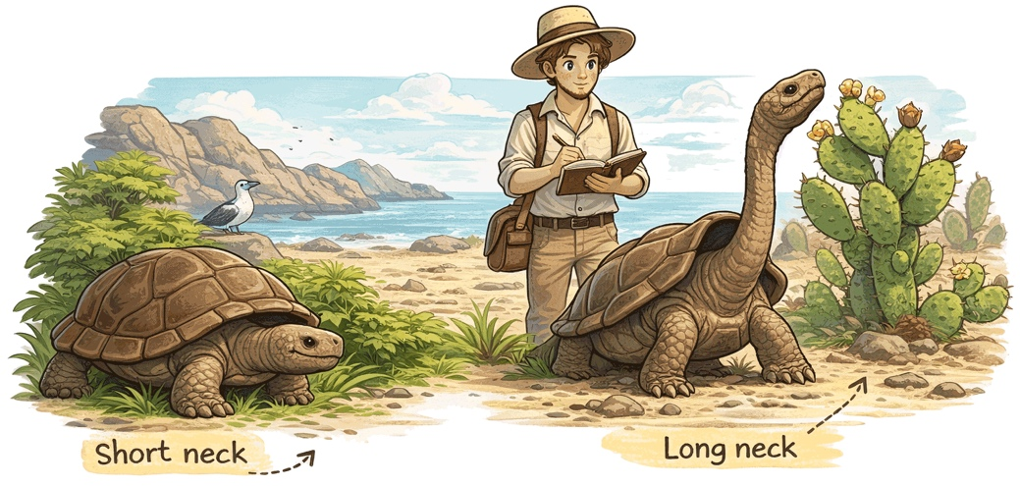
Darwin was still deciding on a career when he embarked on his journey. He came from a family whose wealth allowed him time to choose his own path. He briefly studied medicine, but doctors at the time performed surgery without anesthesia, something he could not stomach. Darwin then prepared for a career in the clergy at Cambridge, where he became deeply interested in natural history, collecting beetles and studying geology and plants. When the captain of the HMS Beagle began searching for a naturalist to join the voyage, a professor from Cambridge recommended an uncertain but promising young man—and before long, Charles Darwin was preparing to leave England on a five-year journey around the world.
Darwin’s Experience in the Galapagos
When Charles Darwin was developing his theory of evolution, he often thought about his experiences aboard the HMS Beagle in the Galápagos Islands. The Galápagos are a chain of islands off the coast of Ecuador in South America. Their isolation from the mainland—and from one another—seemed especially important to the young naturalist.
He observed that animals on the Galápagos were similar to those on the mainland, but not identical. They also varied from island to island. He realized that these differences were suited to their environments.
On the Galápagos Islands, Darwin observed that tortoises differed from island to island in ways that matched their environments. On wetter islands, many had dome-shaped shells and short necks, allowing them to graze on plants close to the ground. On drier islands, some had saddleback-shaped shells that curved upward in the front, letting them stretch their necks to reach higher vegetation such as cactus. These differences helped each group survive and showed how species can adapt over time.

He spent the next twenty years studying nature, gathering evidence, and conducting experiments to develop his ideas. When he felt he had enough evidence, Darwin wrote On the Origin of Species.
Darwin was careful to base his ideas on what he observed. He did not address human evolution, but other scientists later applied his ideas to explain how we evolved. His book sparked intense debate in England and the United States. Many religious leaders objected to Darwin’s conclusions because they conflicted with their reading of the Bible, but some clergy found value in his ideas.
Darwin’s theory of evolution did not answer every question, but it changed how scientists study life on Earth. Today, evolution is a central idea in biology, supported by fossils, genetics, and ongoing research. As new evidence is discovered, scientists continue to build on his work. His greatest contribution was not just a single idea, but a new way of understanding the natural world, grounded in careful observation and evidence.

Fill in the Blanks
C__a__l__s D__rw__n explained how s__e__i__s change over time through n__t__r__l selection. As a young naturalist, he traveled around the world and observed small d__f__e__e__ces among p__a__ts and a__i__a__s. He realized that individuals with traits suited to their e__v__r__n__e__ts were more likely to s__r__i__e and r__p__o__u__e. Drawing on ideas from animal b__e__d__ng, he saw that nature also “selects” traits when resources are limited. After years of study, Darwin published On the O__i__in of S__e__ies in 1859. His ideas sparked d__b__te but changed s__ie__ce.
Answer in complete sentences
1. What did Charles Darwin introduce an explanation for?
*2. Describe natural selection in your own words.
*3. Why do you think Darwin’s writings sparked debate in Britain and the United States?
4. What did Darwin observe in the Galápagos Islands that helped him develop his ideas?

