The Olmecs

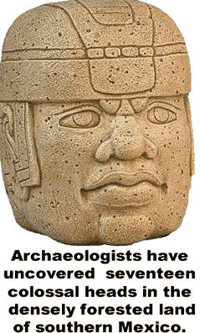
In the late 1850s, near the village of La Venta in southern Mexico, a farmer was clearing land when he discovered a dome-shaped rock. He dug out the land to find a nearly six-foot-tall stone sculpture of a head. Writing on the back of the head later indicated that it was fashioned in 32bce. This unnamed and now forgotten farmer had found the first evidence of the mysterious Olmec culture.
About 1800bce, the Olmecs first appeared in the densely forested land near the gulf coast of southern Mexico. Their population grew as Olmec farmers learned to produce more food. They planted squash, tomatoes and peppers, but their primary crop was corn. The dense jungle was home to the first advanced civilization of Mesoamerica.
The Olmecs studied astronomy and developed a system of writing and mathematics. They were the first Mesoamerican culture to build pyramids. Their calendar and religious beliefs appear to have influenced later cultures. In fact, many scholars call the Olmecs the “mother culture” of Mesoamerica.
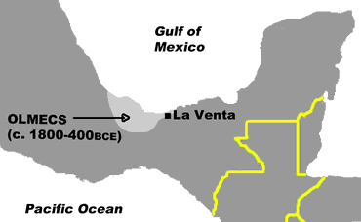
Archaeologists have since uncovered a total of seventeen colossal heads, the latest found in 1994. The largest of the heads is more than eleven feet tall, and they range in weight from six to nearly fifty tons. All of the heads are realistic portraits of men; some of the heads are smiling, while others look calm or angry. All of the heads are wearing what appear to be helmets. Some archaeologists have suggested that the sculptures represent Olmec rulers who played a ceremonial ball game.
We don’t know much about Olmec ball games, but archaeologists have found evidence of courts for playing and stadiums for watching these games throughout the region. The games appeared to be played with a solid rubber ball and seemed to require great skill. Some evidence suggests that the game was played as part of a religious ceremony.
The Olmecs lived in a swampy region with no natural rocks. The basalt stone used to make the heads apparently came from mountains more than one hundred miles away. Olmec workers somehow transported the stone through dense jungles and across major rivers without the use of the wheel.
The Olmecs produced two impressive cities that rose and fell in succession. The first, now called San Lorenzo, grew to occupy nearly three square miles. Then, about 1200bce, San Lorenzo was mysteriously abandoned at about the same time a bigger city grew near present-day La Venta. La Venta, too, was destroyed about 350bce, but again, we don’t know why. The archaeological evidence suggests that the population in the region suddenly declined.
The Olmecs lived in one of the wettest regions of Mesoamerica, so after their cultureretreated, it did not take long for the jungle to reclaim the land. We don’t know if the Olmecs evolved into other cultures, or if they left or died out.
Two hundred years ago, the Egyptian civilization was equally mysterious. But in 1823, Jean Champollion deciphered their hieroglyphic writing. Likewise, archaeologists have made great advances in understanding the history of Mesoamerica in the last few years. So, it is possible that the mysteries of the Olmecs and other civilizations of the region will soon be explained.

Fill in the Blanks
The Olmecs were the first advanced civilization of M__s__a__e__i__a. They first appeared about ______bce in the densely f__r__s__ed lands of s__u__he__n Mexico, near the present-day states of Veracruz and Tobasco. The Olmecs studied a__t__o__o__y and developed systems of w__i__i__g and m__t__e__a__i__s. They also constructed p__r__m__ds and developed a c__l__n__ar.
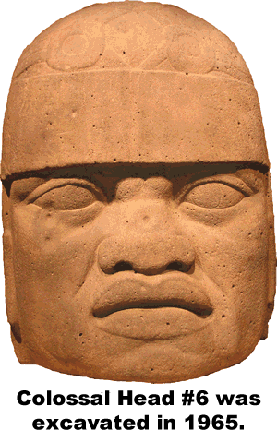
The Olmecs built three ci__i__s that were each mysteriously a__a__d__n__d at different times. An even greater mystery is what happened to the Olmecs as a culture. The evidence suggests the p__p__l__ti__n of the region suddenly dropped about ______bce. The f__r__st reclaimed their land and the Olmecs stayed hidden from history for perhaps as long as two thousand years.
The culture remained unknown to the *m__d__rn world until the late 1850s, when a Mexican f__rm__r found a *s__a__ue of a man’s h______. Archaeologists have since uncovered seventeen c__l__s__al heads in the region. The statues are complex portraits of men wearing h__l__e__s. Some of the statues portray s__i__i__g men, while others show faces that are ca__m or a__g__y. Scholars have suggested that the statues represent Olmec r__l__rs dressed for a b______ g______.
The Olmecs lived in a s__a__py region with no natural stone from which to *c__r__e the c__l__ss__l heads. Without the use of the *w________, they somehow transported the stone through jungles and over rivers from m__u__t__i__s more than one hundred miles away. Olmec sculptors fashioned the heads with s__o__e tools because metallurgy was unknown in the region more than two *t__o__s__nd years ago.
Answer in complete sentences
*1. Why was the Olmec civilization unknown to the modern world until the late 1850s?
*2. According to the text, what crops allowed the Olmec population to grow?
3. Why have many scholars dubbed the Olmecs the “mother culture” of Mesoamerica?
*A higher order learning question. Any reasonable answer will be accepted.

