The Incas

It is 1493, and you struggle to breathe the thin mountain air of the Andes Mountains more than 10,000 feet above sea level. From afar, you witness a grand spectacle: the arrival of Huayna Capac, the ruler of the Four Regions.
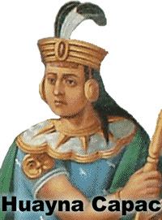
Huayna Capac is carried in a great chair because he never walks in public. The ground is too dirty to accept his saliva, so the ruler spits into the hand of an attendant. The attendant then wipes his hand with a special cloth. The cloth and anything Huayna Capac has touched was sacred. It would eventually be burned in a great ceremony so that it did not fall into the hands of common people.
Huayna Capac was the Sapa Inca, or “sole ruler” of Tawantinsuyu, a local word that means “four regions.” We know Tawantinsuyu by the title of their powerful rulers: the Incas. The Incas formed one of the world’s greatest empires in the forbidding climate of the Andes, the tallest mountains of the Western Hemisphere.
The people believed the Sapa Inca was a living god, whose ancestor was Inti, the sun god. The Incas believed Inti was their protector because his light provided life for the crops and the people. Even the Sapa Inca was careful to respect the sun god.
Quilla was the moon and Inti’s wife. The Incas would watch throughout the month as Quilla would grow from a small sliver in the sky to a beautiful sphere that lit the night, only to recede and return the next month. The children of Inti and Quilla were the stars.
Despite the severity of the high altitude climate, the Incas were at least the third empire to develop in the Andes. The Chavìn controlled the coastal regions of what is now Ecuador, Peru, and Bolivia as early as 900bce. They were followed by the Wari (500 – 1100) and the Tiwanaku (tee-wan-AH-ku) (300 – 1000ce) in the south. The Inca did not gain prominence until after the fall of the Wari and the Tiwanaku.
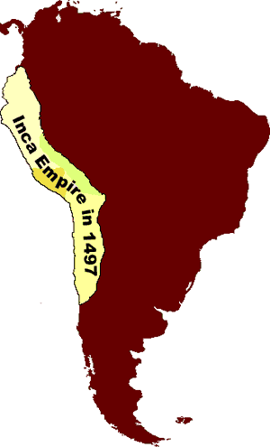
Pachacuti (pah-chah-COO-tee)— Huayna Capac’s grandfather—ruled from 1438 to 1471. Pachacuti transformed the kingdom of Cusco in modern Peru to a mighty empire through negotiation and warfare. He sent representatives to local rulers inviting them to join his empire. If the local ruler refused, Pachacuti sent his brutal army to force them to give up.
Pachacuti was probably the emperor who ordered the construction of the mysterious Machu Picchu. Located 7000 feet above sea level near Cusco, Machu Picchu probably served as a country estate for Pachacuti. The site includes more than 200 buildings and three large temples. Because the city was inaccessible for hundreds of years to outsiders, it is the best remaining example of an Inca city.
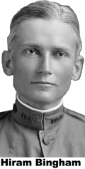
For hundreds of years, explorers had heard tales of a city so high it was always hidden by clouds. In 1911, Yale professor Hiram Bingham found Machu Picchu and later wrote about it in National Geographic. Bingham has often been compared with Indiana Jones in “Raiders of the Lost Ark.” The “Lost City of the Incas” is now easily reached by railroad. Every year, thousands of tourists flock to what has become the most familiar icon of Inca civilization.
In 1532, Francisco Pizarro conquered the Incas and claimed their land for Spain. By that time, the glory of the Inca empire had faded. Huayna Capac and his eldest son died only a few days apart in 1527, possibly from smallpox. The European disease seems to have reached the Andes even before the arrival of the first Spanish conquistadors.
The Inca Empire fell into the hands of Huayna Capac’s younger sons, who fought a civil war that weakened the empire. Wracked by disease and divided leadership, the Incas were no match for the guns and cannons of their invaders.

Fill in the Blanks
The Incas lived high in the A__d__s Mountains of South America during the *f__f__e__n__h century. They called themselves Tawantinsuyu, the land of the f______ r__g__o__s, but we know the Incas by the title of their r__l__rs. Sapa Inca, or “s______ ruler,” was believed to be the decendant of I______, the sun god who ruled with his wife, Q__il__a, the goddess of the m____n.
The Incas were the last and most powerful of several pre-*C__l__m__i__n empires in the Andes. A warrior named P__c__a__u__i transformed the kingdom of C__s__o into a powerful empire through *w____ and diplomacy. Pachacuti likely to have ordered the construction of M__c__u P__cc__u as a country estate. The “l______ city of the Incas” was unknown to outsiders until its discovery by Yale professor Hiram B__n__h__m in 1911.
The empire of the Incas began to crumble shortly after the death of H__ay__a C__p__c in 1527. Huayna Cupac may have died of s__a__lp__x, a E__r__p__an disease that appears to have reached the Andes years before the *c__n__u__s__a__o__s. Within five years of Huayna Cupac’s death, the Incas fell to a small band of warriors led by Francisco P__z__r__o.
Answer in Complete Sentences
1. Explain why the people had such great respect for the Sapa Inca. Use specific statements from the text to support your answers.
2. Explain how Pachacuti used negotiation to build his empire.
*3. Why was Machu Picchu hidden from the outside world until 1911?
*4. Most of the Inca roads have been destroyed or are overgrown, but if this were 1497, what advice would you give to a traveler about to take a journey through the empire of the Incas? Your advice should be based on facts from the article.
*A higher order learning question. Any reasonable answer will be accepted.

