Name: | 
Date:

The Islands

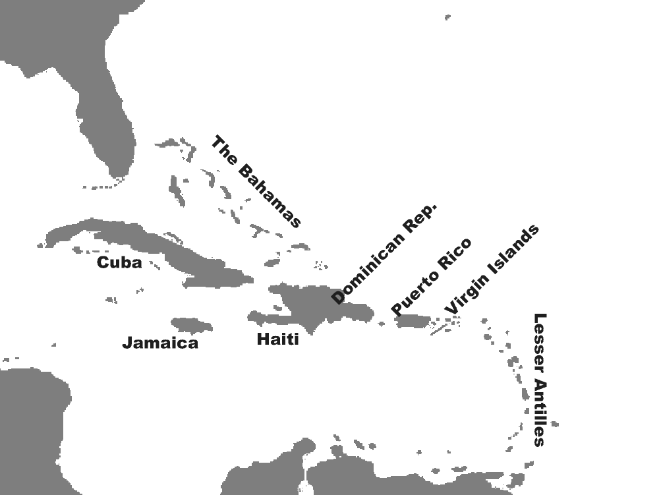
A vast volcanic mountain chain lies along the floor of the Caribbean Sea. The tops of some of the mountains extend beyond the water to form many of the islands of the region. Other islands are cays (pronounced keez), low-lying coral islands, formed over thousands of years from the accumulation the skeletal remains of tiny sea animals.
The islands of the region are divided into three main groups—the Bahamas, the Greater Antilles, and the Lesser Antilles. The Bahamas is an archipelago, or a group of 700 islands north of the Caribbean Sea. People inhabit only about thirty of the Bahamian islands. South of the Bahamas are the largest islands of the Caribbean, called the Greater Antilles. The Greater Antilles include Cuba, Jamaica, Puerto Rico, and Hispañola. The largest islands of the Greater Antilles have rugged mountains and lush, thick rain forests. Hispañola is home to two nations: Haiti and the Dominican Republic. Most of the rest of the Caribbean islands form an arc that stretches from Puerto Rico to the coast of South America. These islands are known as the Lesser Antilles.

Fill in the Blanks
Many of the i____________ of the C_________________ Sea are part of a vast *u__d__r__e__ mountain c________. Other islands are c________, low-lying c________ islands formed from the *b__i__d__p of *s__a__l sea c_______________.
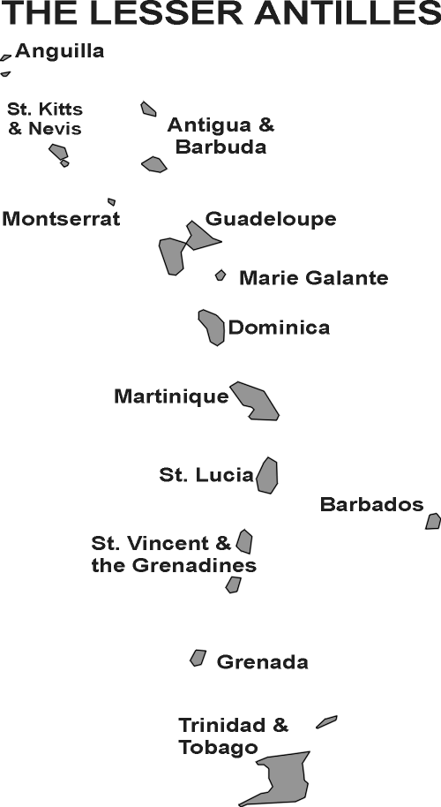
The C________________ islands are divided into t________ groups. The B____________ is an a___________________ of more than s________ hundred i____________ located n________ of the C________________ Sea. The Greater Antilles, including C______, Jamaica, H________________, and P__________ Rico, are the l____________ islands in the *r__________. Some of the islands have rugged m______________ and thick r______ forests. The Lesser A______________ form an a____ that stretches from P__________ R______ to the c________ of S________ America. These islands are known as the L________ A______________.

Answer in complete sentences
*1. Why are most of the Bahamian islands uninhabited?
2. How were cays formed?

