Name: | 
Date:

Haiti

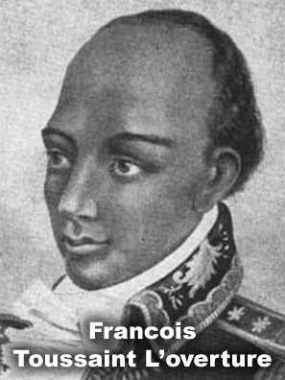
The French colonized Haiti, and built huge sugar plantations on the fertile Haitian soil. Sugar farming is very hard work, and the plantation owners forced African slaves to work very hard to keep up production. In 1791, the Africans revolted under the direction of Francois Toussaint L'overture. In 1804, after years of bitter and bloody battle, the slaves forced the French to flee the island. The former slaves then formed the first independent black nation. There had been many great black kingdoms in Africa, but never before had a black government replaced a white colonial government.
Unfortunately, the former slaves had no experience in government. Slaves had not been allowed to be educated, so almost nobody could read or write. The black government was not recognized by other nations, and the income from sugar production was gone because the sugar plantations had been destroyed in the long war.
Many power hungry men who cared little for their people controlled Haiti. From 1908 to 1915, Haiti had fifteen presidents. The United States took control of Haiti from 1915 to 1934, but the Haitians resented the uninvited Americans.
The Duvalier family ruled Haiti from 1957 to 1986. Francois "Papa Doc" Duvalier was a doctor who specialized in treating malaria. Duvalier ran for the presidency and was elected by the largest majority in Haitian history.
Once in power, Duvalier became a dictator. He was raised a Roman Catholic, but he strengthened his control over Haiti by publicizing his belief in Voodoo. He created a violent military police force known as the Touton Macoutes. (pronounced TOE-tan mow-COO), who tortured or killed many of Papa Doc’s opponents. During Papa Doc’s rule, most of Haiti’s educated people fled the country, leaving it the poorest and most illiterate nation in the Western Hemisphere.
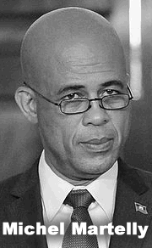
Papa Doc's son, Jean-Claude "Baby Doc" Duvalier followed his father into power. In 1986, the Haitian people revolted and Baby Doc fled to France, but he managed to leave with millions of dollars from the Haitian treasury. A series of short-lived governments followed, most of which were brutal and incompetent.
In 2010, a massive earthquake killed more than 200,000 people and left millions homeless. Despite international assistance, Haiti is still recovering from the catastrophe. A year after the earthquake, the Haitian people elected Michel Martelly to be their leader in free elections.

Answer in Complete Sentences

1. Who was Francois Toussaint L’overture?

Name:
Date:

Fill in the Blanks
Francois Toussaint L’________________ led a H____________ slave r__________ in 17____ against the F__________ plantation o___________. After *t______________ years of *f______________, the slaves d______________ the F__________ and formed the f________ independent b________ nation.
The former s__________ had no e__________________ in g__________________. Slaves had not been a____________ to be e______________, so few people could r______ or w________. Other nations *r__f__s__d to r________________ or trade with the *b_______ government, and the i__________ from s________ production was gone.
Haiti was ruled by the D______________ family for ____ years. Francois, “P______ D____” Duvalier was a d__________ who s___________________ in treating m___________. He was e____________ by the largest m_____________ in Haitian h____________, but became a d______________ one he gained p________. Papa Doc s______________________ his c____________ over H________ by p________________ his b_________ in V__________. He created a v____________ military f________ known as the T__________ M______________, who t______________ or k__________ many of D________________’s opponents. In 19____, the H____________ people r______________ against Duvallier’s, son, J______-C__________, nicknamed “B______-D____.”
Haiti's faced another great challenge in 2010 when a catastrophic e__r__h__u__ke killed more than ____________ people and left m__l__i__ns homeless.

Answer in Complete Sentences
*2. Explain why Haiti been extremely poor during most of its post-colonial period.
*3. Who was Francois Duvalier?
*4. Why did most of Haiti’s educated people flee the nation during Papa Doc’s rule?

