Name:
Date:
A TERRIFYING LEGACY

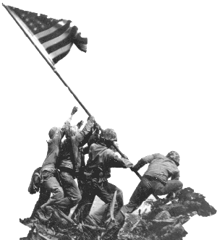
The primary legacy of the twentieth century is war. The rich industrial nations of the world developed destructive technology and used it in ways that came close to destroying the world. The century included two global conflicts, World War I and World War II, and climaxed with the invention of a weapon that killed hundreds of thousands of people, and eventually had the potential to destroy the humanity.
We have come to accept the recklessness of World War. Today there are organizations such as the United Nations to help keep peace, and instantaneous communication allows people to understand what is happening throughout the world. We are unlikely to experience a global conflict in our time, but it is important to understand how close the world came to ruin, and how the forces of the past century influence our lives.
It is impossible to describe a topic as vast as the World Wars in a few short pages. The villains are more monstrous, the heroes more courageous, and the victims more tormented than most imaginations allow. Steven Spielberg’s films, Schindler’s List and Saving Private Ryan, are graphic and inappropriate for younger students, but they help demonstrate the evil, the daring, and the grief of global warfare.

Fill in the Blanks
The rich i____________________ nations of the t________________ century developed destructive t__________________ that came close to d__________________ the e________. The *s__c__n__ of two worldwide *c__n__l__c__s ended with the i________________ of a nuclear w__________ that had the p__________________ to destroy the entire *p_________. An uneasy “C_____ War” between the U________ States and the S________ Union followed the w______.

Answer in Complete Sentences
1. What is the dictionary definition of legacy?
*2. Several nations have had the ability to destroy the earth as we know it for close to a half-century, but a nuclear weapon has not been used in war since August 1945. Why do you think the nations of the world have not used their most deadly weapons?

