The Holocaust

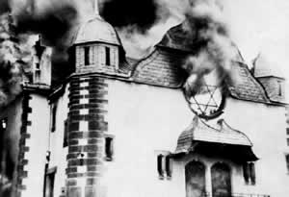
When the Nazi party took control of Germany, people who did not fit Adolf Hitler’s view of the perfect Aryan German race faced extermination. Targets included Jews, Slavs, the Roma (Gypsy) people, homosexuals, the mentally handicapped, and others.
On November 9, 1938, the world got its first glimpse of the terror that lay head for Jews in Germany. German gangs attacked and burned synagogues and Jewish business throughout Germany. Jewish hospitals, homes, schools and cemeteries were also vandalized. The night became known as Kristallnacht, or the “night of the broken glass.” Some 30,000 Jews were arrested and placed in prisons called concentration camps.
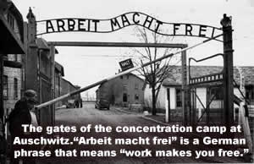
The Nazis used the concentration camps for many atrocities. Camp prisoners were used as slave laborers and were often worked to death. The Nazis conducted cruel medical experiments without using anesthesia.
In time, the Nazis adopted a policy of genocide, the deliberate and systematic extermination of a group of people based on their race, religion, or culture. The concentration camps became death camps with gas chambers for mass killings. Many prisoners were forced to dig their own graves. Once the graves were dug, the prisoners were shot. Those who survived the shooting were buried alive. Other prisoners were starved to death, or died from lack of medical care. One of the cruelest atrocities involved “showers.” Naked men, women, and children were herded into a large room expecting to be showered with water. Instead, poison gas filled the room, causing a cruel, p ainful death. The bodies were then removed and cremated.
Altogether, as many as six million Jews and five million others perished in what became known as the Holocaust. After the war, the Allied Powers convicted the Nazi leaders for “crimes against humanity,” for their atrocities. The few survivors of the Holocaust have implored the world to never let the world forget the tragedy for the Jewish people, or for any people. More than half a century after the Holocaust, institutions, memorials, and museums continue to teach the history of the Holocaust to future generations.

Answer in complete sentences
1. What was Kristallnacht? Why was the event significant?

Fill in the Blanks
Adolph Hitler argued that G____________ would r__________ to g________________ if “o________________” were purged from the nation. His N______ party began to e____________________ people who did not fit H__________’s view of the perfect A________ race. Jews, S________, the R______, homosexuals, and the h____________________ were considered unfit by the N________. The Nazis forced the people they considered to be unfit into c________________________ camps where *pr_________________ were often worked to death. The Nazis performed many cruel experiments on the concentration c______ prisoners, often without a__________________. As many as s____ million J______, and f______ million others p______________ in what became known as the H________________.

Answer in complete sentences
2. What is the dictionary definition of atrocity? (See atrocious if the dictionary leads you there.)
3. What is genocide?
4. Approximately how many people perished in the Holocaust?
5. Why have the survivors of the Holocaust implored the people of the world to not forget the lessons of the Holocaust?

