Name:
Date:

The Doughboys

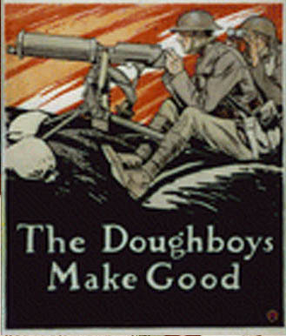
America declared war, but several months passed before soldiers reached the front. First, Americans had to be persuaded to join the war. The idea of conscription, drafting soldiers to fight, was unpopular with many Americans, but 2.8 million Americans were ultimately called to duty. Once drafted, the soldiers were quickly trained and dispatched to Europe.
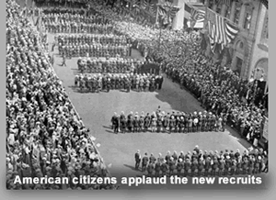
The war weary French people were thrilled to see American soldiers march through the streets of Paris on July 4, 1917. The soldiers were treated as celebrities. Many French people threw candy or cigarettes to the soldiers to show their appreciation. An American officer announced Nous voici, Lafayette! (Lafayette, we are here!) The Marquis de Lafayette helped train George Washington’s troops in the American Revolutionary War. The phrase suggested that America was ready to repay an old debt to an old friend.
The British and French planned to use the Americans as reinforcements for their fallen forces, General John J. Pershing, the leader of the American forces, disagreed. Pershing insisted that the Americans fight together and not be spread among other Allied Forces. He understood the importance of the spirits of the soldiers. George M. Cohan captured the feelings of many sol diers in “Over There,” a song popular in the United States during the war, and proudly sung by soldiers on their way to the front.

Over there, over there,
Send the word, send the word, over there
That the Yanks are coming,
the Yanks are coming,
And we won’t be back
‘Till it’s over over there.

The American soldiers fighting the Great War were often called “doughboys.” The meaning of the term is obscure, but the spirit of that nickname and many others helped build a sense of camaraderie among the fighting men. The eager doughboys helped lead the Allied Forces to victory in the Great War.

Name:
Date:

Fill in the Blanks

The first A______________ soldiers reached France two m__________ after C______________ declared w____ in 1917. The weary F__________ people were *d__l__ght__d to see A________________ march through the s____________ of P________; many showed their g__a__i__ude by throwing c________ or c__________________. When the Parade reached the tomb of the M____________ de L__________________, Col. Charles Stanton announced in French, “L___________________, W__ A____ H______.” The phrase suggested that A______________ was about to r________ an old d______ to the F__________ nobleman who helped t________ George W__________________’s troops almost 150 *y________ earlier. The A_______________ forces fought under the direction of General John J. P______________, who insisted that A________________ fight t________________ and not be s___________ among A__________ forces. The American “d______________’s” fighting s__________ helped the A__________ forces to v____________ in the G________ War.

Answer in complete sentences

*1. Why do you think many Americans had to be persuaded to join the Great War?
*2. Approximately how long has France been at war when the American soldiers arrived?
*3. Why did General Pershing insist that American soldiers fight together instead of being used as “replacements” for fallen British and French soldiers?

