The Medici

The Medici were a prominent family that produced four popes and two French queens. They controlled the Italian city-state of Florence from 1434 to 1737 and were among the most wealthy and powerful families of Europe during the Renaissance.
Florence has been a prosperous city in the Tuscany region of central Italy for centuries. After the fall of the Roman Empire in the west, a number of prominent families took control of the city and often fought wars among themselves. In the 15th century, the leading families of Florence decided they needed a strong person in charge to take charge of their city. They chose Cosimo de Medici to take control of the government.
Florence and the Italian Language
In 1861, the newly united Italian government began a national literacy program to unify a kingdom with many languages and dialects. Even the King, Victor Emmanuel, spoke either French, or Piedmont, a dialect of Italian spoken in northwest Italy. They declared the Tuscan dialect spoken in Florence—not the Latin dialect spoken in Rome—to be Italian, the national language of the Italy.

The Medici had been a prominent family in the region for centuries. Their name suggests a relationship with medicine; perhaps an ancestor might have been a doctor. The later Medici were shrewd businessmen whose Medici Bank was the largest and most respected financial institution of the Renaissance.
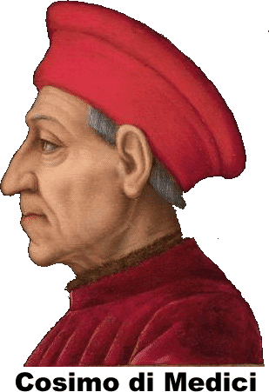
When Cosimo took control of the city, he maintained the appearance of republican government by appointing relatives and people he could control to important positions. And sure enough, when Cosimo died after thirty years in power, his son and grandson continued his policies.
Cosimo’s grandson, Lorenzo, was not only a shrewd banker and clever politician; he was also a scholar and a poet. Under Lorenzo’s leadership, Florence became one of the most beautiful and prosperous cities on the Italian peninsula, as well as a center of the Renaissance.
The Medici were patrons who funded artists and scientists. Lorenzo was a patron of Leonardo di Vinci. Galileo Galilei tutored several generations of Medici, though the family withdrew their financial support for the scientist when the church charged Galileo with heresy.
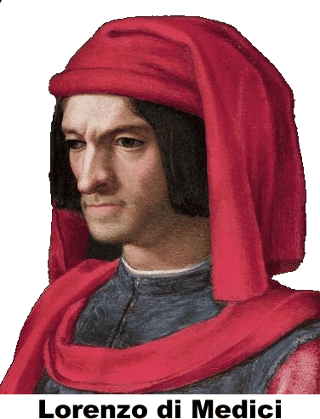
The last Medici ruler died without an heir in 1737. Florence came under Austrian and later French control for more than a century. In 1861, the Florence briefly became the capital of the newly unified kingdom of Italy.

Fill in the Blanks
The leading families of F__o__e__ce chose C__s__mo de M__di__i, a wealthy b__n__er to take control of their g__v__r__m__nt in 1434 The *F__o__i__t__n__ families wanted a s__r__ng person to lead them against the growing threat of rival cities.
Cosimo maintained the a__p__a__a__ce of r__p__b__i__an government, but he appointed r__l__t__v__s and people he could c__n__r__l to important positions. Cosimo died in 14____, but the Medici family continued to control F__o__e__ce for nearly three *c__n__u__i__s.
Cosimo’s g__a__d__on, Lorenzo, was the most famous member of the M__di__i family. Lorenzo was a shrewd b__n__er and a clever p__l__t__c__an along with being a s__h__l__r and a p____t. Under the leadership of “L__r__n__o the Magnificent,” F__o__e__ce became one of the most beautiful and prosperous cities on the Italian *p__n__n__u__a, as well as a center of the R__n__i__s__n__e.

Answer in Complete Sentences

1. Who were the Medici?

2. Explain how the Medici kept control of Florence for generations.

*3. Lorenzo di Medici was a Renaissance Man because he had wide interests and was an expert in several areas. Name a man or woman in our society who fits that definition. Explain your reasoning.

