Johann Gutenberg’s Invention

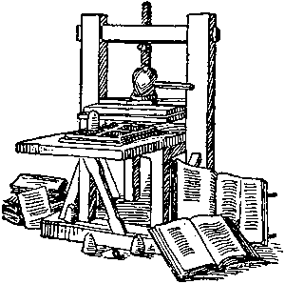
A good cook can take leftovers and turn them into a delicious meal. Like a good cook, Johann Gutenberg took what had already been discovered and created a small invention that had a large impact on history. About 1450, Gutenberg crafted the printing press, a machine that allowed him to move small blocks of letters in such a way that written material could be printed and mass-produced.
We don’t know much about Gutenberg because he was not famous during his lifetime. He was born in Germany about 1400 and worked as a goldsmith. In 1448, Gutenberg developed engraved signatures for each number, letter, and punctuation mark. He then built the molds to hold the signatures in place and borrowed money to purchase a press.
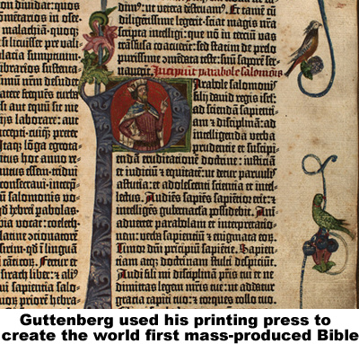
Printing using blocks existed long before Gutenberg’s time. The Chinese had been carving wood blocks to print books as early as 868, but the Chinese process required making a new set of woodcuts for each book. Producing one page was difficult; producing a volume with many pages was not practical.
Block printing existed long before Gutenberg’s time. The Chinese had been carving wood blocks to print books as early as 868, but the Chinese process required a new set of woodcuts for each book. Producing one page was difficult; producing a volume with many pages was not practical.
Writing ink dates from about 2500bce, developed separately in Egypt and China. Earlier inks were a mixture of soot from fires and sap. Later civilizations used the dark blue indigo plant. Gutenberg used an oil-based ink because it lasted longer than other inks used at that time.
Gutenberg published the first mass-produced book: a 1,282-page edition of the Christian Bible. To this day, more copies of the Bible have been printed than any other book.
Copies of Gutenberg’s invention spread throughout Europe, but unlike today’s inventors the German goldsmith did not get rich from his new technology. Other people built machines without compensating Gutenberg. Modern inventors are protected in most nations by patent laws. A patent is a government license that gives an inventor the exclusive right to sell their creation for a period of time.
Some religious and government officials denounced invention of printing because they feared that it would spread rebellious ideas, but they were unable to stop a literacy revolution in Western Europe. By 1500, there were 1,700 printing presses in Europe. These presses had already produced about 20 million volumes of 40,000 different books. Guttenberg’s small invention changed the course of history.

Fill in the Blanks
About 1450, a German g__l__s__i__h named Johann G__t__n__e__g constructed a machine that allowed him to move small b__oc__s of l__t__e__s in such a way that w__i__t__n material could be p__i__t__d and mass-produced. Gutenberg’s first *p__b__i__a__i__n was a 1,282-page edition of the Christian B__b__e.
Although Gutenberg’s i__v__n__i__n changed history, the printing press did not make him w__a__t__y. Others built similar machines without c__m__e__s__t__ng Gutenberg. Today, p__t__nt laws in most nations p__o__e__t the inspiration of i__v__n__o__s.

Answer in complete sentences
*1. Why did literacy increase after Guttenberg invented the printing press?
2. What was the biggest drawback of Chinese block printing?

3. Why did Johann Gutenberg not become wealthy from his invention?
*4. Should artists and inventors be paid for the inspiration? Should people be allowed to freely copy the works of others? Defend your answers.

