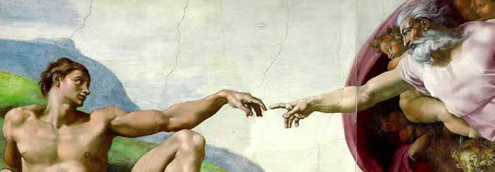
Renaissance Art

Renaissance patrons wanted art that showed joy in human beauty and life’s pleasures, which is why the art of the Renaissance is more lifelike than in the art of the Middle Ages. Renaissance artists studied perspective—the differences in the way things look when they are close to something or far away. Renaissance artists painted in a way that showed these differences. As a result, their paintings seem to have depth.
An artist from Florence named Giotto was one of the first to paint in this new style. Giotto lived more than a century before the beginning of the Renaissance, but his paintings show real emotion. The bodies look solid, and the background of his paintings shows perspective. Renaissance art would build upon Giotto’s style.
The ceiling of the Sistine Chapel is one of the world’s most famous paintings, but not everyone was happy with Michelangelo’s work. Cardinal Biagio de Cesena noted that the crowd of more than 300 human figures would be more appropriate in a wine shop than in a papal chapel. Michelangelo responded to this criticism by adding a portrait of Biagio among the figures of the damned in the scene of the Last Judgment.
Leonardo da Vinci was born in 1452 in the village of Vinci. His name means Leonardo of Vinci. Leonardo began his career working for a master painter in nearby Florence.
Leonardo’s fame grew—but not just for his painting. Leonardo was truly a “Renaissance Man,” skilled in many fields. He was a scientist and an inventor as well as an artist. He made notes and drawings of everything he saw. Leonardo invented clever machines and even designed imitation wings that he hoped would let a person fly like a bird.
People have been trying to guess the secret behind the smile of Leonardo’s Mona Lisa ever since he painted it around 1505. His Last Supper shows clearly the different feelings of Jesus and his followers.
Michelangelo Buonarroti of Florence was one of the greatest artists of all time. Like Leonardo, Michelangelo was a “Renaissance Man” of many talents. He was a sculptor, a painter, and an architect. When Michelangelo carved a statue of Moses, he included veins and muscles in the arms and legs.
Michelangelo was a devout Christian, and the church was his greatest patron. He designed the dome of St. Peter’s church in Rome. Nearby, Michelangelo’s paintings cover the ceiling of the Sistine Chapel, the building where new popes have been selected for more than five hundred years. Michelangelo’s painting illustrates the Book of Genesis, with scenes that span from the Creation to the Flood. The project was very difficult. Working alone, Michelangelo had to lie on his back atop high scaffolding while he painted the vast ceiling.

Answer in Complete Sentences
*1. How was Renaissance art different from the art that preceded it?

Fill in the Blanks
Renaissance artists and their p____________ expressed themselves through *p_____________ and sculpture long before the advent of the electronic media. Renaissance p____________ wanted a____ that showed j____ in human b_________ and life’s p________________. Renaissance a____ is more l______________ than the a____ of the M_________ A______. Renaissance artists studied p___________________, or the d____________________ in the w____ things l______ when they are c________ to s________________ or f____ away. Perspective gave R__________________ paintings the illusion of d________.
A Florentine a__________ named G__________ was one of the f________ to p________ in this n____ style. Giotto’s p________________ showed real e____________. People and objects are less *f______ in his work. Leonardo da V________ was a man of many t____________. Leonardo’s art included the mysterious M______ L______, but he was a “R___________________ Man,” with s__________ in many fields. L______________ was also a s________________ and an i______________. Like Leonardo, M______________________ Buonarroti was another “R____________________ Man.” Michelangelo was famous as a s____________, a p____________, and an a________________. He d_______________ the d______ of St. P________’s church in R______. Nearby, M______________________’s paintings cover the c____________ of the S____________ Chapel.

Answer in Complete Sentences
2. What was unique about Michelangelo’s Moses?
3. What did Michelangelo paint on the ceiling of the Sistine Chapel?
*4. Why would the church want a Michelangelo’s painting on the ceiling of the Sistine Chapel?

