THE NORMANS

The Vikings were fierce warriors from northern Europe, who plundered England and the coast of continental Europe throughout the Middle Ages. One group of Viking warriors settled in France and eventually conquered England in 1066.
In 910, Frankish king Charles the Simple made a deal with a group of Vikings. Charles allowed the Vikings to settle in northwest France on two conditions: The settlers had to agree they were part of Charles’ empire, and their leader, Rollo, had to convert to Christianity. The Viking settlers became known as Normans—men from the north—and their land known as Normandy. During the next 150 years, the Normans adopted both Christianity and French customs, though they interacted with other Viking cultures and the Royal House of England.
England is part of Great Britain, an island off the northwest coast of continental Europe. In the fifth century, two Germanic cultures, the Angles and the Saxons conquered the native Britons after the Roman army retreated from the island. In 1066, Anglo-Saxon King Edward the Confessor died, causing a three-way fight for the English crown.
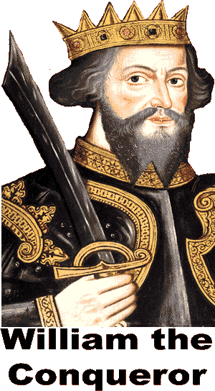
The English nobles chose Harold Godwinson as the next king. Godwinson and his army faced two challenges: King Harold Hardrada of Norway led an army from the south, while William of Normandy posed a threat from the southwest. Godwinson’s army marched north to defeat Harold’s army.
At the same time, Edward crossed the narrow English Channel with his Norman army. The Normans built a fortified castle in England, and while Godwinson’s army was away, William’s army pillaged the English countryside. To pillage is to take things by force.
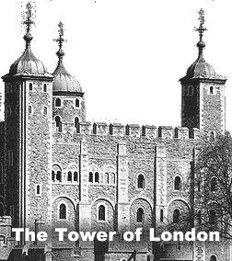
Harold Godwinson rushed his forces to meet the Normans, but the exhausted English army was no match for the well-prepared invaders. William the Conqueror’s Norman army killed Godwinson and subdued the English forces in the Battle of Hastings.
William the Conqueror distributed the wealth and property of the Anglo-Saxon nobles to about 200 Normans. The Normans built the imposing Tower of London to protect the capital; the tower also served as a reminder to the English people of the power of the Normans. William completed a survey of the population and the wealth of England. The result was the “Domesday Book” of taxation. Both the Tower of London and the original Domesday Book still exist today.
After 1066, England would be ruled by kings who did not speak English. The Normans imported French-speaking craftsmen, cooks, and scholars. The modern English language reflects the high status of the French Normans and the low status of the English field hands. We refer to animals in the field by their English names (cow, ox, sheep), while food that has been prepared and brought to the table generally has French names (beef, veal, mutton).
In 1204, King Phillip II of France conquered Normandy in the Anglo-French War. His army forced the English to retreat to Great Britain. After the conflict, English rebel nobles forced their king, John I, to sign a document that declared everyone, including the king, was subject to the same laws. The Magna Carta--or Great Charter-- became the basis of English legal system and centuries later served as an inspiration for the United States Constitution.

Fill in the Blanks
The Normans were V__k__ng warriors who settled in northwest F__a____e in the *e__g__th century. Over time, the Normans adopted the French c__l__u__e and converted to C__r__s__i__n__ty, but they intermarried with the Royal House of E__g__a__d. England is a k__n__d__m on the i__l__nd of Great Britain.
England's name is derived from the A__gl__s, one of two G__r__an__c cultures that controlled the kingdom from the fifth century. The Angles and the S__x___s conquered the native B__i__o__s after the fall of the R__m__n army.
When A__gl__-Sa__on King Edward the C__n__e__s__r died in 1066, his *h__ir, Harold G__d__i__s__n, faced two foes. Godwinson's English army defeated a *N__r__e__i__n army led by Harold Hardrada, but the Englishmen were no match for the Norman army of William of N__r__a__dy, later known as William the C__n__u__r__r.
William distributed the wealth of the Anglo-Saxon n__b__es to a small group of N__r__a__s. For nearly the next four c__n__u__i__s, rulers who did not speak the *n__t__ve language controlled England. The English were forced to retreat to Great Britain in 1204 as Phillip II of France conquered N__r__a__dy in the Anglo-French War. After the war, the English nobles forced their king to sign the M__g__a Carta. The Magna C__r__a declared that e__e__y__ne, including the k______, was subject to the same l______.

Fill in the Blanks
- Why do we call the Vikings who settled in northwest France the Normans?
- Who were the Anglo-Saxons?
*3. Give one example where modern English language reflects the high status of the Normans and the low status of the English.

