THE MOORS

Muslim warriors crossed the narrow Strait of Gibraltar in the eighth century to invade the Iberian Peninsula at the southwest corner of Europe. Muslims controlled part or most of present-day Spain and Portugal for the next 800 years.

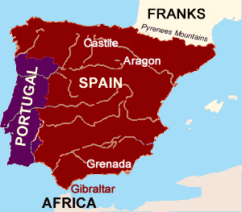
In 409, the Roman government in Spain fell to Germanic speaking warriors called Visigoths, or Western Goths. The Visigoths migrated into the Roman Empire from the east to escape the Huns. During the three centuries that followed, Christianity spread through the peninsula, and the Visigoth’s Germanic culture blended with the native population of the peninsula.

Arab and Berber Muslims crossed the nine-mile wide waterway between Africa and Europe In 711, to land on a mountain of stone that juts out from Spain. The Spanish called the invaders Moors, a term that means “dark-skinned.”

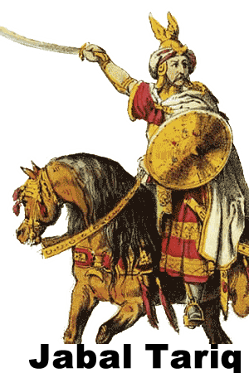
The leader of the 10,000 invaders was Jabal Tariq, and the point where the Muslim army landed became Mount Tariq. The local people pronounced Jabal Tariq as Gibraltar. We now call the narrow channel that separates Europe from Africa the Strait of Gibraltar, and Mount Traiq as the Rock of Gibraltar.

Tariq’s army met with little opposition from the Visigoths, so they managed to control most of the peninsula by 719. The Moors were never able to control all of the Iberian Peninsula because several small Christian kingdoms remained in the north. Tariq’s army crossed the Pyrenees Mountains and attempted to invade the land we now call France in 732, but the Muslim army was defeated at the Battle of Tours by Charles Martel, the grandfather of Charlemagne.

For the next three hundred years, Spain was known by its Arabic name, Al-Andalus. The Moors were tolerant of the Christian and Jews who lived in the land they conquered, but they taxed the people who did not share their Islamic faith at a higher rate. As a consequence, many citizens converted to Islam to avoid paying higher taxes.

The Moors formed a caliphate, or religious center, in Cordoba. Scholars studied the works of the Greek and Roman authors while artists and architects established the city as a center of the arts. Cordoba also became a center for the study of mathematics, astronomy, and agriculture.

A civil war among the Muslims in the eleventh century caused the collapse of the caliphate into small kingdoms called taifas. The disunity allowed for the Christian reconquest of Spain.

Christian warriors began the Reconquista, or reconquest of the peninsula 1085. The Christian kingdoms of Castille and Aragon in northern Spain won several military victories. After years of fighting, a nobleman named Afonso expelled the Muslim rulers from the western part of the peninsula and established the Kingdom of Portugal in 1139. By the end of the thirteenth century, only the Emirate of Granada in southwest Spain remained under Muslim control.

In 1469, the two most influential Christian kingdoms on the peninsula united through the marriage of Ferdinand II of Aragon and Catherine of Castile. These “Catholic kings” built roads and standardized laws and coinage throughout their kingdoms. In 1492, armies of Ferdinand and Isabella captured Granada, the last Muslim territory in Spain. Soon after, the monarchs ordered all Muslims and Jews to either convert to Christianity or leave their kingdom.

As the Muslims retreated to Africa, Spain began to look west. The same year that Ferdinand and Isabella banished Jews and Muslims from Spain, Isabella financed the sailing expedition of Christopher Columbus, which led to the establishment of a Spanish Empire in the America.

Fill in the Blanks
The Moors were M__s__im warriors who crossed the Strait of G__b__a__t__r to conquer and control the I__e__i__n Peninsula for nearly ______ years. The Moors conquered the G__r__a__ic Visigoths, who replaced the R__m__ns in power on the peninsula 300 years earlier.
In 711, J__b__l T__r__q led a Muslim army of A__a__s and B__r__e__s into S__a__n. The rock where the warriors landed and the strait they crossed are now called G__b__a__t__r, a S__a__i__h word derived from J__b__l T__r__q's name. Tariq’s army conquered the *s__u__h__rn part of the I__e__i__n Peninsula, but many small C__r__s__i__n kingdoms survived in the north. The Muslims crossed the P__r__n__es Mountains to fight the F__a__ks in the Battle of T__u__s in ______, but they were routed by an army led by C__a__l__s M__rt__l.
An eleventh-century civil war led to the fall of C__r__o__a; and A__-A__d__l__s broke apart into several small t__if__s, leaving the Muslims vulnerable to the Christian R__c__n__u__s__a.
Christian warriors, particularly from C__s__i__le and A__a__on, forced the M__s__i__s to withdraw to G__e__a__a by the end of the t__i__t__e__th century. Once the *m__n__rc__s of C__s__i__le and Aragon m__r__i__d in 1469, Christian armies in Spain became a unified force. By the sixteenth century, F__r__i__a__d and I__a__e__la had banished the M__s__i__s from the peninsula.

Answer in Complete Sentences
1. What was significant about the city Cordoba during Moorish rule?
2. How did the Moors treat the Christians and Jews of Al-Andalus?
3. What was the Reconquista?

