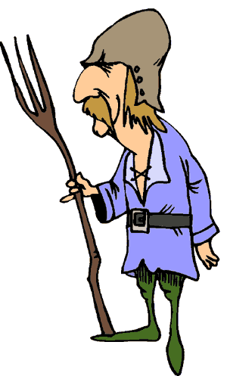
FEUDALISM

By the ninth century, the rulers that filled the void after the fall of the Roman emperors in Western Europe were often incapable of controlling all of their lands. In exchange for loyalty, a king often granted an estate, called a fief, to a noble. The nobles constructed large estates on their fiefs called manors. This system of loyalties and protections is known as Feudalism, a term derived from the fiefs.
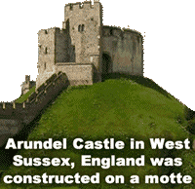
The Lord and his family often lived in a castle, a fortified building constructed to be safe from enemy attack. These castles were unlike the images from fairy tales. They were built for protection rather than comfort. When under attack, the people of the manor retreated to the castle for protection.
Motte-and-bailey castles were constructed on large mounds called mottes. The earth used to build the motte formed a ditch. A drawbridge over the ditch could be retracted when an enemy approached the manor. The bailey was the area below the castle where most of work of the manor was done.
The nobles pledged to train knights, mounted warriors who fought using swords and lances. The introduction of stirrups, supports for the rider’s feet hanging from the saddle, allowed cavalry to remain on their horses. A knight attacking on horseback with a lance tucked under his arm caused tremendous damage to his foe. The galloping horse was also a moving target that was difficult for an enemy force to attack.
Peasant farmers needed the noble’s protection as German, Viking, Magyar, and Moorish armies overran small houses and farms throughout Europe. Some peasants were freemen who owned or rented land from the Lord, but most were serfs.
Serfs could not be sold like slaves, but they could not leave their manor without permission from the Lord. The Lord provided the serf and his family a safe place to live and land to grow food. In exchange, serfs were required to work a particular number of days on the lord's personal fields.
Serfs were not allowed to marry without permission from the Lord; the family of a serf would have to turn over additional crops when someone wanted to marry and leave the manor. Serfs were encouraged to have many children because a small family might not have enough daylight hours to tend their family plot after their work in the Lord's fields was complete. Lords often forced families to pay a tax when a member of their household died to compensate for the manor's loss of labor.
There was very little social mobility, or chance to move upward in status during the Middle Ages. A serf who lived on the manor of a Lord was likely the descendant of a peasant who had served the ancestor of that Lord. For centuries, a person’s life was all but guaranteed to be exactly like their parents' lives.
The feudal system proved impractical by the end of the Middle Ages. A terrible disease called the Black Death claimed the lives of millions of Europeans in the fourteenth century, so in many places there were not enough peasants to farm the vast estates. The introduction of gunpowder and long-range cannons made knights fighting with swords on horseback an outdated form of warfare that was expensive to train and support.
At about the same time, cities were growing in population for the first time since the fall of the Roman Empire. These changes in society would lead to the Renaissance—the rebirth of Europe and the beginning of modern history.

Fill in the Blanks
During the Middle Ages, W__s__e__n European rulers often granted land to nobles. In exchange, the noble pledged his l__y__l__y and provided the king with trained horsemen called k__i__h__s. This system of loyalties and protections is called f__u__a__i__m.
The noble and his family often lived in c__s__l__s that were built for p__o__e__t__on rather than c__m__o__t. The castles were constructed on raised mounds called m__tt__s. A vast estate called a M__n__r surrounded the castle. As L__r__s of the Manor, the n__bl__s provided p__a__a__t farmers with p__o__e__ti__n and land on which to grow food. The farmers r__p__id the noble by w__r__i__g in his p__r__o__al fields in addition to f__r__i__g their land.
The feudal system ended in Western Europe by the end of the M__d__le Ages. Millions of p__a__a__ts lost their lives from a widespread *i__l__e__s called the Black D__a__h, so there were not enough workers to farm the M__n__rs. The cost of maintaining k__i__h__s became unnecessary once rulers learned of g__n__o__d__r and long-range c__n__o__s. Meanwhile, as European cities grew in p__p__l__ti__n for the first time since the fall of the R__m__n Empire, the feudal age gave way to the R__n__i__s__n__e, the rebirth of Europe.

Answer in Complete Sentences
1. How did the introduction of the stirrup change military warfare during the Middle Ages?
2. Why were peasants of the Middle Ages willing to live on a Manor?
3. How were serfs different from other peasants during the Middle Ages?
4. Why did many peasants who lived on Manors desire large families?
*5. The text states "There was very little social mobility during the Middle Ages." What does this phrase mean?

