Sparta

Sparta was an ancient Greek polis that was surrounded by enemies, so Spartan citizens began preparing for war at birth. Spartan rulers examined newborn babies to determine if they were healthy and strong enough to be of value to the polis. The rulers killed sickly or malformed infants deemed incapable of contributing to the security of Sparta.
Spartans had to conform to strict rules. Spartan boys would leave their homes at age seven to begin training as warriors. The boys would live in military housing called barracks where they faced rigorous training and discipline. Spartan trainers underfed the boys. If they caught a boy stealing food, the boy was beaten--not for stealing but for being caught. Spartan men could marry when they were twenty years old, but Sparta did not allow the men to live with their families until they reached thirty. A Spartan soldier who had not found a wife by age thirty would customarily capture an unmarried woman of his choice. Spartan men would continue to serve in the military until they were sixty years old. Both men and women in Sparta competed in athletic contests to keep physically fit.
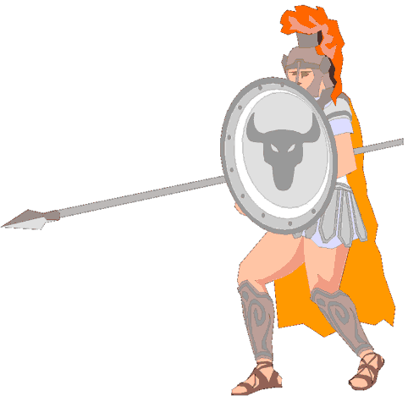
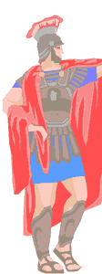
Spartan men were constantly in training for war, so women completed many of the duties of running the polis. Woman were the sole owners of at least one third of Spartan land. Spartan girls were raised to be tough so the women could bear strong children for the polis. The people of other poli would tell the story of a Spartan mother who killed her son for running away from his duties. Spartan women were known for being stoic. A stoic person can endure pain or hardship without showing their feelings or complaining. When Spartan soldiers went to battle, their mothers and wives would present the warriors with their shield and say: "With this, or upon this." The soldier was expected to return to Sparta either victorious with his shield in hand, or be carried home dead upon his shield. If a Spartan soldier returned home alive and without his shield, the soldier faced banishment from the polis or death.
The Spartans were Dorians who invaded the land they occupied on the Peloponnesus, a peninsula in southern Greece. Spartan warriors expanded their territory by capturing neighboring lands. They called the people they captured helots. The Spartans forced helots to farm the land the helots once owned, but the helots had to provide half of their harvest to Sparta. A Spartan police force spied on the helots and killed anyone suspected of being a threat. Every year, Sparta would declare war on the helots and Spartan warriors would kill helots as part of their training.
Spartan laws discouraged anything that would distract citizens from their disciplined military life. Sparta did not welcome visitors from other cities, and did not allow their citizens to travel. The Spartans were not interested in other ways of life and did not want to bring new ideas to their polis. Today, we use spartan as an adjective to describe someone who leads a rigorously disciplined life that includes few comforts or luxuries.
Sparta’s army eventually came into conflict with Athens, a trading poli that developed the strongest navy of ancient Greece. In 431BCE, Sparta and Athens began a twenty-seven year long conflict called the Peloponnesian War. The Romans conquered Sparta in 146BCE, ending centuries of independence for the polis. In 1834, Greece began construction of a new city on the site of ancient Sparta. Modern Sparti is a small city with fewer than 20,000 inhabitants that lives on among the ruins of one of the most powerful cities in history.

Fill in the Blanks
Sparta was an a__c__e__t Greek p__l__s that was always p__e__a__ed for w____. Male Spartans would begin their t__a__n__ng as soldiers at age s________. Soldiers faced rigorous training and harsh d__s__i__l__ne while often being u__d__r__ed. Spartan w__m__n were in charge of many of the *d__i__y routines of the polis because the men were t__a__ni__g for war. Spartan women were known for their ability to endure p______ and h__r__s__ip and were prized for their ability to b______ strong Spartan w__r__i__rs.
The Spartans e__s__a__ed many neighboring farmers the Spartans called h__________. Helots led harsh lives filled with *c__u__l__y. The Spartans forced the helots to turn over h______ of their crops to f______ the Spartan a______. Each year, Sparta would declare w____ on the helots and r__w__rd the s__l__i__rs who k__l__ed helots.
Sparta was a d__s__i__l__n__d society that built a strong a______, but Sparta d__s__o__r__g__d new ideas and v__s__t__rs from other poli. Sparta would eventually come into conflict with A___________, a polis that *t__a__ed with others and e__c__u__a__ed new ideas. Sparta won the brutal P__l__p__n__e__i__n War with Athens, but Sparta eventually fell to a R________ army in 146bce.

Answer in complete sentences
*1. What statements in the text suggest why it was necessary for the Spartans to always be prepared for conflict?
2. Why were young Spartan soldiers punished for stealing?
*3. Why does the text imply it was necessary for the Spartans to terrorize the helots?
4. Why did Sparta discourage visitors and travel?

