GREEK MYTHOLOGY

The beliefs of the ancient Greeks were full of the violent storms, volcanoes and earthquakes that were a part of their experience. Greek mythology is based on legends passed down through generations by word of mouth, so there are many versions of Greek mythology and not all of the stories agree with one another.
Myths explained nature, taught moral lessons, and provided entertainment. Greek poets created epic stories based on ancient legends. An epic is a long poem about great heroes and their deeds.
Like most ancient cultures, the ancient Greeks were polytheistic, but unlike other cultures, many of their gods looked and acted like human beings. The ancient Greeks believed their gods had unlimited powers, yet Greek gods married, had children, played tricks and fought great battles with one another. The ancient Greeks attributed natural disasters to conflicts among their gods.
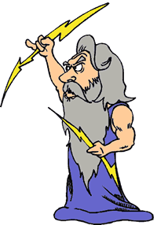
A Greek poet named Hesiod wrote that the Earth goddesses emerged from nothingness called Chaos. The earth mated with the sky to produce the Titans. The Titans were giants who ruled over Greece from atop Mount Othrys. The giants were led by Cronus until he lost a great war with his children. The children of Cronus were called the Olympian Gods because they lived atop Mount Olympus, the highest mountain in Greece.
Zeus was the youngest son of Cronus and the head of the Olympian pantheon. A pantheon is a family of gods. Zeus was also the god of rain who ruled the sky with his powerful thunderbolt. Ancient Greek farmers relied on the rain they believed came from Zeus, but they also feared the anger of Zeus during violent thunderstorms.
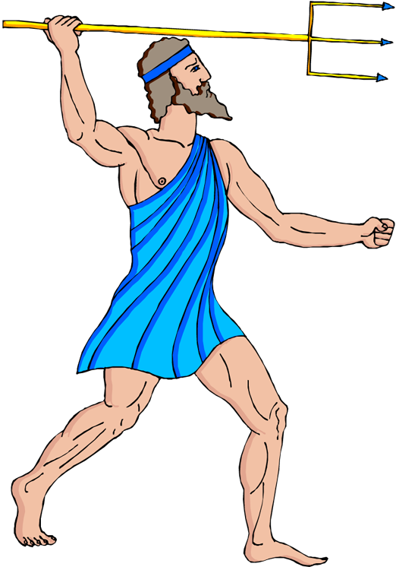
Poseidon was said to be Zeus’ brother and the ruler of the sea. Greek mariners and fishermen believed Poseidon had the power to create earthquakes by striking the ground with his mighty trident. A trident is a three-pronged spear used by the ancient Greeks both as a tool and a weapon. Poseidon might cause shipwrecks with his trident, but could also create new islands and favor sailors with food and safe travel to other lands.
A third brother named Hades ruled the underworld. The Greeks believed that people passed to Hades’ territory when they died, and while they were treated fairly in the underworld, Hades would never allow them to return to the world they once knew.
Greek legends say Zeus’ favorite daughter was Athena. Athena was the goddess of wisdom and courage. Legends say Athena gave the Greeks the olive tree. Olives are a staple of the Greek diet. The Greeks also use olive oil for cooking, fuel, and as a medicine. When the Greeks fought one another, they appealed to Athena because she was also the goddess of just warfare.
Most people no longer share the beliefs of the ancient Greeks, but humanity still finds great inspiration in the stories and symbols of Greek mythology.

Answer in complete sentences
1. How were the Greek gods different from the gods of most other ancient cultures?

Fill in the Blanks

The ancient Greeks believed in many gods, so they were p__l__t__e__s__ic. The battles of the Greek gods reflected the st__r__s, volcanoes and e__r__h__u__k__s that were a part of ancient Greece. Greek mythology is based on *o______ legends, so some stories do not agree with others. In an epic poem called Theogony, Hesiod wrote that the E__r__h and the s_y formed the Titans. The Titans were g__a__ts who ruled the earth until their defeat in a great b__t__le with the O__y__p__an gods.

Zeus was the r__l__r of the p__nt__e__n of Olympian gods. Farmers depended on Zeus because he was the god of r______, but Zeus could also terrify people with his powerful th__n__e__b__lt. His brothers were P__s__i__on and H__d__s. Poseidon was the god of the s____. When angered, Poseidon would s__ri__e the g__o__nd with his t__i__e__t to create e__r__h__u__k__s. Hades ruled the u__d__r__o__d. Athena was the goddess of w__s__om and c__u__a__e. The Greeks often appealed to A__h__na before going to w____ because she was the g__d__e__s of just w__r__a__e.

The stories and legends of the ancient Greeks explained n__tu__e, taught m__r__l lessons and provided e__t__r__a__n__e__t. While the b__l__e__s of the ancient Greeks are no longer widely practiced, many people still find i__s__i__a__i__n in the stories and symbols of Greek m__t__o__ogy.

Answer in complete sentences
*2. If you grew up in ancient Greece, how would you have learned the stories of Greek mythology?
3. Who were the Titans? Why did the ancient Greeks believe the Titans lost power?
4. How were Zeus, Poseidon, and Hades related?
*5. Zeus was the most powerful Greek god. What do his powers suggest the people of ancient Greece feared?

