Name: |  |  | 
Date:

THE CRADLE OF WESTERN CIVILIZATION

The civilization of ancient Greece flowered more than 2500 years ago but the ideas of the ancient Greeks continue to influence the way we live today. Greece is made up of a peninsula and group of islands in southeastern Europe. A peninsula is a piece of land that is almost surrounded by water. The people of ancient Greece attempted to explain the world through the laws of nature. The ancient Greeks made important discoveries in science. They developed democracy, where people govern themselves rather than being ruled by a king. The Greeks also valued beauty and imagination. They wrote many stories and plays that continue to be performed today.
The people of ancient Greece could not farm most of their mountainous, rocky land, so they became excellent sailors who traveled to distant
lands. Greek sailors learned from many different cultures and spread their ideas to many lands far from their home. The Greeks learned the alphabet from the Phoenicians, a sea-faring people from modern day Syria and Lebanon.
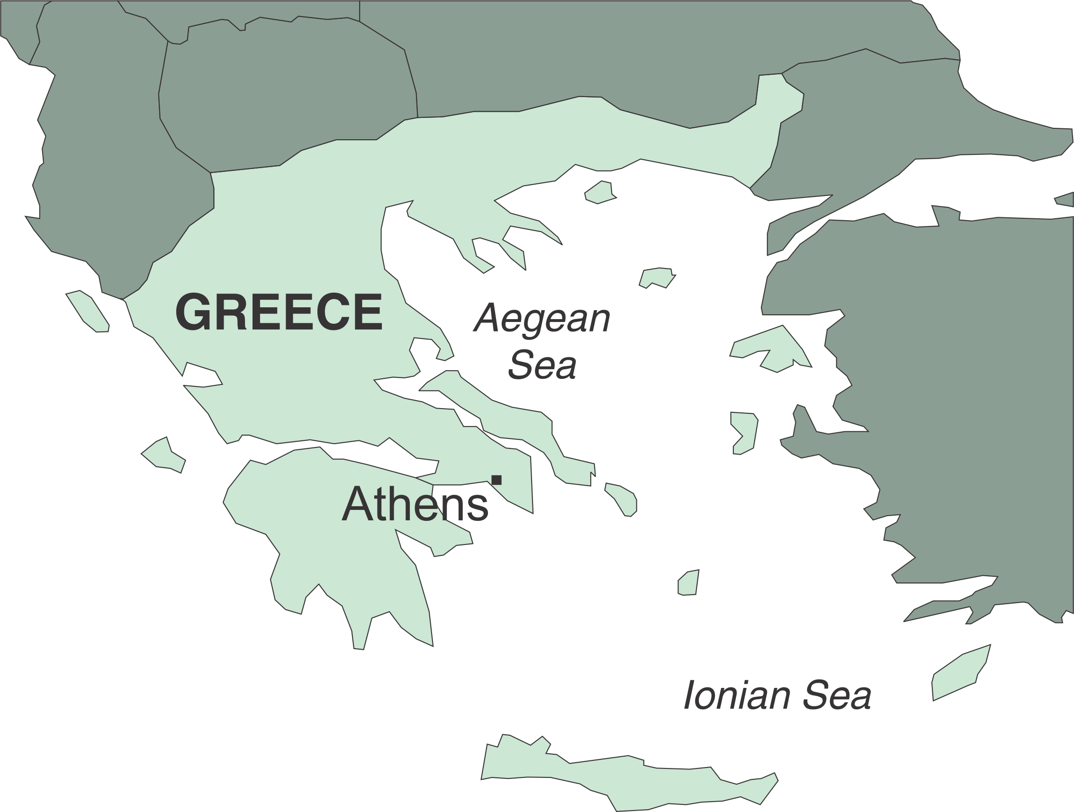
Ancient Greek geographers divided the world into regions we still use today. The lands west of Greece are still known as the western world, while the lands east of Greece are often referred to as the eastern world.
A cradle is a small bed for an infant. Many of the ideas that flourished in the western world were “born” in ancient Greece. This is why Greece is often known as the Cradle of Western Civilization.

Fill in the Blanks
The ancient G_________ introduced many valuable i_______ that i_______________ the way we live today. The Greeks lived on a small, rocky p_______________ in southeast E_________. They were unable to f_____ most of their l_____, so they turned to the s____, where they became excellent s___________.

Answer in complete sentences
*1. Why is most of Florida a peninsula?
*2. Why is the United States a democracy?
*3. Give examples of describing how ancient Greece influences our lives today.
*4. Why is the United States considered part of the western world?
*5. Explain why the Greeks might not have had a great influence on the world if they had better farmland?

