Athens and Democracy

Athens is the capital and largest city in modern Greece, but Athens also has a long history that dates back 7000 years. Modern ideas about democracy first developed in ancient Athens. Unlike Sparta, it was difficult for the rulers of ancient Athens to have complete control over their citizens. Athens developed as a merchant poli whose ships traded with many faraway places. The traders were exposed to many new ideas.
The first Athenian rulers were warriors who controlled the poli by force. The warrior families called themselves aristocrats. Aristoi- comes from a Greek word meaning “best people.” The tyrant was the leader of the aristocrats. Today we use the term tyrant to describe a cruel ruler, but many of the Athenian tyrants were kind and effective leaders.
About 622bce, a tyrant named Draco created a written legal system and a court to enforce his laws. Draco’s court meted out harsh punishments for even minor offenses. Today we use the word draconian to describe laws that are unnecessarily harsh or unjust.
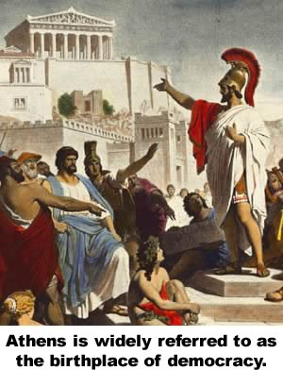
The Athenian army fought in a phalanx, a military formation of soldiers with overlapping shields that moved together as a unit. The mighty phalanx was more powerful than any individual aristocratic warrior. By the time of Draco’s rule, soldiers no longer needed to be wealthy enough to afford a horse, so Athenians from less prosperous families could join the army. The aristocratic leaders learned to consider the needs of all Athenian families to keep from losing support from the army.
In 594bce, Solon became the leader of Athens. Solon repealed Draco’s harshest laws assembled a group of ordinary citizens to vote on how Athens was to be governed. The Assembly gathered forty times a year and was open to all male citizens with at least two years of military service.
The word for people in ancient Greek was demos. Kratos meant rule. The government created by Solon was a democracy, where the people ruled the polis. Most democratic nations have elected representatives to make laws, but Athens was a direct democracy because the citizens acted as lawmakers.
Direct democracy was possible in ancient Athens and even today is the system by which many small towns operate. However, gathering all citizens together to make decisions is not practical in large countries such as the United States.
A council known as the boule managed the daily affairs of the polis. Members of the boule were not elected; they were chosen randomly from the Assembly so that every qualified person had an equal opportunity to serve on the council. At the end of the year, members of the boule appeared before the Assembly to account for their work.
Only adult males born in Athens participated in the assembly. Athens encouraged outsiders to move to their polis, but only free-born males could vote. Women could own property but were not allowed to participate in the democratic process. The members of the Assembly had time to work on public affairs because slaves did most of the physical work in the polis. About one in four people living in Athens were slaves.
Consequently, the members of the Assembly accounted for only about one-fourth of the total population of Athens.
Participation in government by common people was an idea that eventually became a model for other nations. The democratic government in Athens inspired the writers of the American Constitution. Athenian democracy was limited, but it gave some people the opportunity to make decisions about how they were governed.

Answer in complete sentences
1. Who were the aristocrats of ancient Athens?
2. According to the definition provided by the text, why was Draco a tyrant?
*3. Make up a draconian punishment for something that may happen today.
4. Explain why the phalanx was a factor in the development of Athenian democracy.
5. How did Solon change how Athens was governed?
*6. How was the assembly an example of direct democracy?
*7. Why the members of the boule chosen by lot instead of in an election? Do you think this is a good idea?
8. Explain why Athenian democracy was limited.
*This is a higher order learning question. You must answer the question to the best of your ability, but any reasonable answer will be graded as correct.

