Name: |  |  | 
Date:

The Silk Road

The Roman people learned of silk, a beautiful fabric that came from a mysterious place in the east. The fabric was soft and seemed to glow. Clothing made of silk was a source of pride and a sign of great wealth. Even the smallest pieces of silk would be displayed by wealthy Romans.
The Silk came from China, and the Chinese were careful to keep the secret of how they made the beautiful fiber. We know today that silk is made from a sticky substance produced by silkworms. The silkworms are not actually worms, but the tiny caterpillars of silkmoths. When silkworms hatch, they are fed mulberry leaves until they are big enough to spin cacoons. Silk makers boil the cacoons and extract the shimmering fibers that are woven into silk.
Silk traveled west to Rome and other parts of Europe on what historians would later call the Silk Road. The Silk Road was not an actual road, but a 4,000-mile long network of trade routes that connected China to Europe, the Middle East and North Africa. Very few people traveled the entire length of the Silk Road. Trade resembled a chain, with each trader and segment of the trade route representing a link in the chain.
In addition to silk, Chinese merchants sold tea, spices and jade. Jade is a hard, shiny stone used to create beautiful carvings. In exchange, the Chinese received gold, silver, precious stones, glass, ivory, horses, elephants and wool.
Many Europeans first became aware of China when the armies of Alexander the Great expanded his empire along the Silk Road into Central Asia. In 329BC, Alexander founded the city of Alexandria Eschate ("Alexandria the Furthest") about 400 miles west of the Chinese frontier. In the centuries that followed, trade grew between the Roman Empire in the west and the equally extraordinary Han Dynasty in China.
Travel was very dangerous along the Silk Road. Merchants who traveled the routes were often robbed and killed. In the thirteenth century, Mongol armies used the Silk Road to expand their empire. The first Mongol warriors were nomadic warriors who attacked and looted the markets along the trade routes, but in time, the Mongols developed their own efficient trade along the Silk Road.
In 1269, Marco Polo traveled from his home in Italy to China on the Silk Road. His book about his adventures became well-known, but Polo’s stories of China were so amazing that many Europeans could not believe they were true.
Ideas also traveled the Silk Road. Buddhism was introduced to China during the Han Dynasty by merchants from India. Over time, Buddhism lost much of its influence in India, but became very popular in China.
The Black Death was a devastating illness that took the lives of nearly half of the people of Europe between 1348 and 1350. Scientists believe the plague began as a bacterial disease in Central Asian rats. People on land were usually safe because the rats did not like the smell of their horses, but at the western of the Silk Road, goods were loaded into ships on the Black Sea. The ships transported goods to cities throughout Europe. In addition to sailors, the ships were home to rats and fleas. Fleas living on the blood of the rats bit the sailors on board. When the sailors returned to their homes in Europe, they carried the deadly, contagious disease.
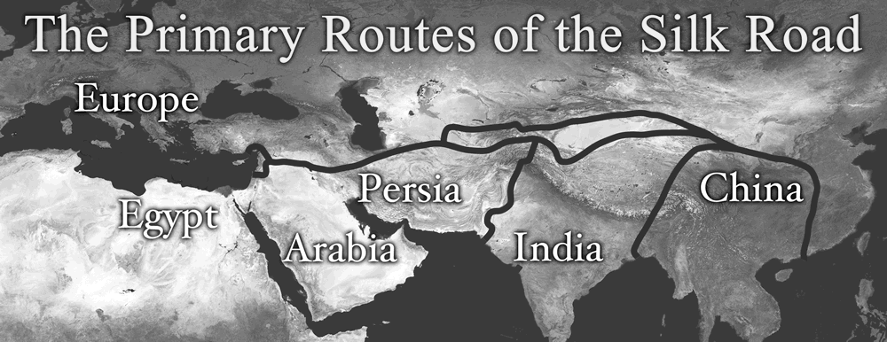
The Silk Road lost its importance when the Mongols Empire disintegrated. The Mongols no longer policed the routes. The Silk Road became even more dangerous when bandits learned to make Chinese gunpowder. By the fifteenth century, Portuguese sailors learned to circumnavigate Africa in order to create sea routes that were faster and safer than the Silk Road.

Name:
Date:

Fill in the Blanks
The Silk Road were a series of t__a_e r__u__es that connected E__r__pe with C__i__a. The routes were named for the beautiful f__b__r produced by Chinese s__l__w__r__s, but m__r__h__n__s also traded t__a, s__i__es, j____e, g____d, s__l__er and i__o__y along the Silk Road. Many Europeans first became aware of China when A_e__a__d_r the G_e__t expanded his e__p__re into Central Asia. A *c__n__u__y later, trade flowed between the R__m__n E__p__re in the west and the H__n D__n__s__y in China. In addition to goods, B__d__h__sm traveled the Silk Road and became an important part of Chinese culture.
Mongol warriors *d__s__r__y__d and later *r__b__i__t the Silk Road, but the trade routes fell into disuse by the fifteenth century. A terrible disease called the B__a__k D__a__h took the lives of as many as half of the European people in the *f__u__t__e__th century. Additionally, bandits made dangerous weapons once they learned how to make g__n__o__d__r from the Chinese. The end of the trade routes came when P__r__u__u__se sailors learned to circumnavigate A__r__ca because the new sea routes were f__s__er and s__f__r then the Silk Road.

Answer in Complete Sentences
1. Why did the Roman people value silk?

*2. Why do you think the Chinese were careful to keep the secret of how they made silk?
3. Explain why the trade routes between Europe and China changed by the fifteenth century.

*This is a higher order learning question. You must answer the question to the best of your ability, but any reasonable answer will be graded as correct.

