Marco Polo

It is the year 1298. A sailor from Venice named Rustichello is in a jail in Genoa, listening to incredible stories from a fellow prisoner. Rustichello and the other man were captured in a sea battle between Genoa and Venice, two Italian city-states at war over control over trade routes in the Mediterranean Sea. The other prisoner described a twenty-four year journey, during which he worked for a rich and powerful ruler in a faraway land we now call China. Before he went to sea, Rustichello was an experienced writer of romance novels, so he was perfectly suited to compile the stories of his fellow prisoner. And he did so in a book he called Description of the World. It is better known, however, as the Travels of Marco Polo.
Marco Polo reported that his great adventure began shortly after meeting his father— Nicoló—in 1269. They met for the first time when Marco was fifteen years old. Nicoló Polo and his brother Maffeo were merchants from Venice. The Polo brothers often traveled to the grand city of Constantinople (now Istanbul, Turkey), where they traded goods with merchants from many Mediterranean and Black Sea ports.
Marco's father and uncle had been away from home for young Marco’s entire life because they continued east from Constantinople to trade in markets along the Silk Road. The Silk Road was a network of trade routes that connected Europe with China. When the brothers attempted to return to Venice, they found their route was blocked by a conflict between two local warlords.
Instead of returning home, the Polo brothers accepted the invitation of a Mongol governor to travel east to meet Kublai Khan, who was the king of all Mongols in his palace in faraway China. Their journey lasted three years.
Kublai Khan ruled a vast and rich land that was unknown to all but a few Europeans. He was impressed with the Nicoló and Maffeo and the stories the brothers told of their Christian faith. The Mongol ruler asked the brothers to return to his palace with 100 Christian scholars and oil from a holy lamp in Jerusalem. The brothers told the great khan this oil would have magic healing powers.
The khan gave the brothers a golden tablet to present along the way. The tablet announced that the brothers represented the great Mongol ruler and were guaranteed his protection on their dangerous journey home.
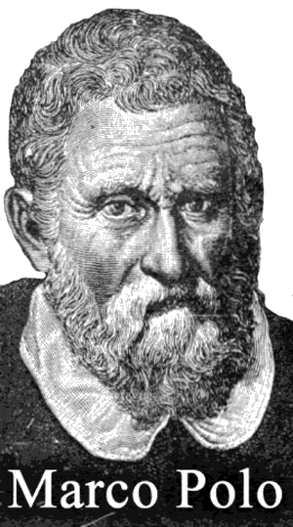
Nicoló and Maffeo Polo returned to Venice to prepare for a second journey to China, but this time they took along Nicoló's son, Marco. Before leaving, the Polos visited Pope Gregory, the head of their church. The Pope gave the Polos many gifts to deliver to Kublai Khan, but instead of the 100 scholars, Gregory sent only two friars.
At the time of Marco Polo, friars were members of the clergy, but friars did not share the status or education of a priest. A friar was addressed a brother while a priest was called father. The friars began the journey with the Polos, but when they saw the dangers they faced on the Silk Road, the representatives of the pope returned home.
Rustichello wrote that the Polo’s four-year journey across the Silk Road provided Marco with first-hand experience of the many cultures of the Middle East and Asia. Finally, they arrived once again at the palace of Kublai Khan, who Marco described as “the greatest lord the world had ever known." Kublai Khan’s palace was surrounded by walls that were four miles long. The palace was decorated with gold and silver and the walls were adorned with beautiful pictures.
Kublai Khan did not trust many of his advisors so, according to Rustichello’s book, he sent Marco to govern a Chinese city for three years. While in China, the Polo family became rich by trading in jewelry and gold.
Marco Polo claimed Kublai Khan would not allow the Polos to return home for seventeen years. Finally, in 1292, an opportunity arose when Kublai Khan asked the family to escort a young woman to Persia to be the bride of one of Kublai's nephews. Persia was an ancient kingdom far west of China, but nearer to the Polos’ home in Venice.
Marco Polo reported that thirteen ships carrying six hundred passengers left China, but by the time the party reached Persia only eighteen passengers remained alive. The Polos also learned that Kublai Khan's nephew had already died by the time they arrived. After leaving Persia, the Polos returned home to Venice in 1295—ending a journey that had lasted twenty-four years.
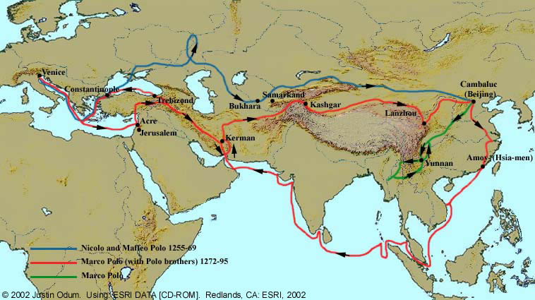
Soon after the Polos returned home, Venice went to war with the rival city-state of Genoa. Marco Polo went to sea to protect his city, but he was captured by Genoa and put in the prison where he met Rustichello.
Rustichello wrote Description of the World before the invention of the printing press, so copies were made by hand. The book delighted its readers and stimulated interest in China and the cultures along the Silk Road. Christopher Columbus owned a copy and studied it closely before beginning his journey in 1492 to what he thought would be China.
Some observers saw Marco Polo as an astute observer with a keen memory. Some of his most fantastic claims are easy for us to understand today. Marco Polo described paper money, unknown in Venice, but which had been used by the Chinese for more than a thousand years. He described a spring that gushed a stream of oil. The oil was said to be tasteless, but good for burning. Marco may have been describing petroleum, or crude oil, which is now used to make gasoline, plastic and other products.
Others argued that Marco Polo made up his stories based on gossip and stories he heard. After all, Marco Polo reported seeing unicorns and he gave a first-hand description of a battle that occurred years before he left Venice. Marco failed to mention the Great Wall of China, tea, or rice. The Chinese have no records of the Polo family, and it is unlikely Marco could have been a governor. Many people described Marco Polo's book as Il Milione ("The Million") for they claimed that it contained a million lies. As an old man, Marco was asked if he invented the stories in his book. His answer was that he barely told half of what he actually saw.

Fill in the Blanks
As a prisoner in an *I__a__i__n jail, a writer named R__s__i__h__l__o learned of the stories of an adventurer who claimed to have spent t__e__t__-f__ur years on a journey to C__i__a where he was employed by a great k______. Rustichello compiled the stories into a volume titled D__s__r__p__i__n of the W__r__d, but the book is better known as the A__v__n__u__es of M__r__o P__lo.
Marco Polo’s f__t__er and u__c__e were t__a__e__s who t__a__e__ed to China when M__r__o was a boy. N__c__ló and M__ff__o Polo impressed K__b__ai K____n, the rich and powerful *M__n__ol ruler of China, with stories about their C__r__s__i__n faith. Kublai Khan asked the Polo brothers to return to China with 100 s__h__l__rs and the o__l from a holy lamp in J__r__s__l__m.
The leader of the Roman Catholic Church, P__pe G__e__o__y, gave the brothers many g__f__s to give to the great khan, but instead of 100 scholars, the pope sent two uneducated f__i__rs to travel with the Polos. In addition to the friars, the Polo Brothers also included N__c__l__’s fifteen-year-old son, Marco, on their second j__u__n__y in 1271. The four year expedition to China acquainted Marco Polo with the many cultures of the M__d__le E____t and A____a. The journey ended at the p__l__ce of a person Marco Polo described as “the g__e__t__st l__rd the w__r__d has ever s____n.”
The Polo family remained in China for s__v__n__e__n years, becoming rich while trading in j__w__l__y and g____d. Marco was selected by the khan to g__v__rn a p__o__i__ce because, according to Marco Polo, the great ruler did not t__u__t his local a_v__s__rs. Kublai Khan would not allow the P____o family to leave C__i__a for until 1292, when he asked them to *a__c__m_a__y a young woman to P__r__ia to be the b__i__e of one of the khan’s n__p__e__s. Most of the *p__s__e__g__rs died on the arduous s__a journey to Persia. When they party arrived, they learned the nephew chosen to m__r__y the young woman d____d. The Polos then returned home to V__n__ce.
Venice and Genoa were two Italian *c__t__-s__a__es who fought over t__a__e routes in the M__d__t__r__a__e__n. Marco Polo went to sea, but he was *c__p__u__ed and put in the p__i__on where he met R__s__i__h__l__o. The b______ they wrote was copied by hand because the p__i__t__ng p__e__s had not yet been invented. The Description of the World was popular with many people, including C__r__s__o__h__r C__l__m__us, who studied the book before leaving on his 1492 voyage to A__e__i__a.
Many people called Marco Polo’s book "T__e M__l__i__n" because they claimed it contained a million l____s. Marco Polo accurately described many things, but he could have simply reported what he learned from others. He also mentioned seeing u__i__o__ns, while failing to mention the G__e_t W____l of China, t__a or r____e in his story. Marco Polo maintained that the stories in his book were all true. In fact, he said, he b__r__ly told h______ of what he a__t__a__ly saw.

Answer in Complete Sentences
1. Why were Marco Polo and Rustichello in prison?
*2. Why was Constantinople a major trading city?
*3. Why do you think Pope Gregory sent two uneducated friars with the Polo family instead of the 100 Christian scholars requested by Kublai Khan?
*4. Why did the Polo family remain in China for seventeen years?
*5. Explain why the Description of the World is one of the most important books in history?
*6. Based on what you have read, do you think that Marco Polo's story is mostly true or mostly false? Use facts from the article to explain your answer.
*This is a higher-order learning problem. You must answer the question to the best of your ability, but any reasonable answer will be graded as correct.

