Name: |  |  | 
Date:

Genghis Khan and Kublai Khan

Genghis Khan was one of the world’s greatest conquerors. The son of a minor chief in what is now eastern Mongolia, he was born in ad1167 and was originally named Temujin. Temujin united the nomadic tribes of Mongolia in a disciplined military state. His followers called him Genghis Khan, or "Universal Ruler."
In 1207, Genghis Khan led the Mongols on the first of many destructive, bloody invasions. Nobody knows exactly how many people were slaughtered by his destructive raids, but even the most conservative estimates suggest that the armies of Genghis Khan killed several million people. Ganghis Khan never learned how to read, but his success as a ruler resulted from his superior military organization, strategy and mobility.
Genghis Kahn’s grandson, Kublai Khan, conquered China and moved his capital to the city now known as Beijing in 1271. Kublai Khan probably did not know how to speak Chinese, but he took the Chinese name Yuan for his dynasty. The Yuan was the only foreign dynasty to rule all of China. At its height, the Mongol empire stretched from Korea to Hungary and as far south as Vietnam. It was the largest empire the world has ever known. The Mongols are remembered mostly for their ferocious military force, but they improved the road system linking China with Russia and promoted trade throughout the empire and with Europe.
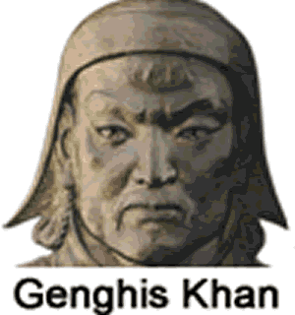
After Kublai Khan died in 1294, the Mongols became less warlike. They were resented as an elite, privileged class exempt from taxation. Several natural disasters and a peasant rebellion caused the Mandate of Heaven to shift to a Buddhist peasant, Hung-wu. Hung-wu expelled over 60,000 Mongols, ending almost a century of Mongol rule and beginning the Ming Dynasty.

Fill in the Blanks
Temujin was born the son of a minor chief in eastern M__n__o__ia, but he is known to the world as G__n__h__s Khan, the “U__i__e__s__l R__l__r” of the Mongol people. The armies of Ganghis Khan *p__l__ag__d much of Asia and Eastern *E__r__pe, killing several m__l__i__n people along the way. The g__a__d__on of Ganghis Khan, K__b__ai Khan, conquered China to begin the Y_____ Dynasty. At one point the Mongol’s created a huge e__p__re that stretched from K________ in the East to the modern nation of H____________ in the west and as far south as V____________.

Answer in complete sentences
*1. What does Ganghis Khan mean? Why do you think that name was appropriate for Temujin?
*2. Do you think the Yuan Dynasty was popular with most Chinese people? Explain your reasoning.

