Name: |  |  | 
Date:

The Great Wall of China

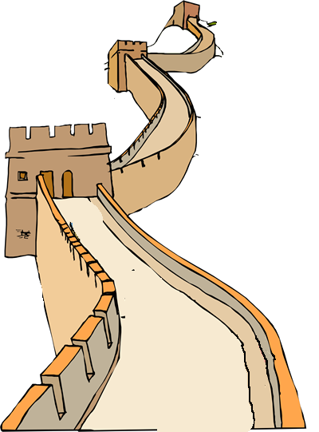
The Mongols were nomadic people who lived north of China. Mongol raids into China caused a great deal of destruction during the Age of Warring States. In 214bce, when Shih Haung-ti unified China and began the Ch’in Dynasty, he decided to end the Mongol threat by constructing one of the largest public works projects in history. To this day, the Great Wall of China is the longest human-made structure on earth. More than a million Chinese workers connected a number of existing defensive walls into a single system fortified by watchtowers in order to keep out the Mongols.
Very little remains of the original construction, but later rulers made the wall stronger and longer. Today the Great Wall of China stretches more than 1,500 miles. The wall is generally twenty-five feet high with forty-foot towers. It is wide enough for wagons to pass each other in opposite directions. If a 1,500 mile wall began in Miami, Florida, it might end in Boston,
Massachusetts, Des Moines, Iowa, Oklahoma City, Oklahoma, or San Antonio, Texas. Gates through the wall became centers of trade and contact with the northern nomads. Ironically, the Song Dynasty fell to Mongol invaders from northeast China when a traitor opened a gate in the wall.
Many people believe that the Great Wall of China can be seen from the moon without a telescope, in fact, a question in the game Trivial Pursuit says as much. Astronaut Alan Bean has been on the moon, and said otherwise.
"The only thing you can see from the moon is a beautiful sphere, mostly white (clouds), some blue (ocean), patches of yellow (deserts), and every once in a while some green vegetation. No man-made object is visible on this scale. In fact, when first leaving earth's orbit and only a few thousand miles away, no man-made object is visible at that point either."
--Quoted in More Misinformation (1980) Malcolm Yapp (Greenhaven Press, Inc.).

Fill in the Blanks

When Shing Haung-ti became the First *E__p__r__r of China in 214bce, he decided the best way to *u__i__y his the C__i__e__e people was to keep the n__m__d__c tribes from the north from *a__t__c__i__g his empire. He c__n__e__t__d a series of existing d__f__n__i__e walls to create what became known as the G________ W______. Today, the G________ W______ of C_______ covers a distance of more than ________ miles. It is the largest m____ m______ structure on earth.

Answer in complete sentences
*1. Approximately how old is the Great Wall of China?
2. Explain why the gates in the Great Wall of China became centers of trade.
3. What role did the Great Wall of China have in the fall of the Song Dynasty to Mongol invaders?

