Dynasty

From at least 1766bce to the twentieth century of the Common Era China was ruled by dynasties. A dynasty is a ruling family that passes control from one generation to the next. A dynasty does not have to last for a long time. One Chinese dynasty lasted more than 800 years while another lasted only fifteen years.
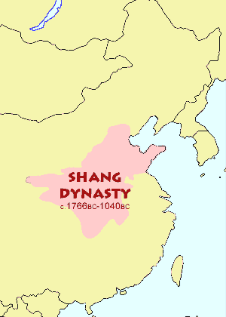
The ancient Chinese believed their ancestors in heaven had chosen their leaders. They called this the Mandate of Heaven. The Chinese people often rebelled against a weak leader if they believed he had lost the Mandate of Heaven.
There are indications of an earlier Xia Dynasty (pronounced she-ah*), but the Shang were the first dynasty to leave written records. The Shang Dynasty ruled China from approximately 1766bce to about 1040bce. Shang rulers expanded the borders of their kingdom to include all of the land between present-day Mongolia and the Pacific Ocean.
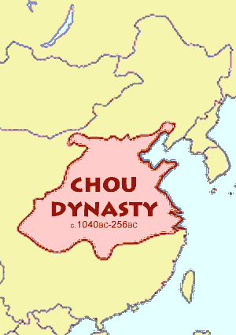
The Shang practiced human sacrifice. If a Shang ruler died, many of his subjects would join the ruler in his grave. Some people were beheaded first but others were buried alive. When a Shang king died, his next oldest brother replaced him. When there were no brothers, the oldest maternal nephew became king. A maternal nephew would be a child of one of the deceased king’s cousins – that is, a son of h`is mother’s siblings.
The Zhou (joe*) were nomads who lived west of the Shang. They overthrew the Shang and ruled China from 1040bce to the third century before the Common Era. The Zhou gained power, in part, from their ability to extract iron from rocks. They used the metal to create powerful weapons.
The Zhou developed a feudal system in China. In a feudal system, the rulers appoint nobles to rule smaller parts of an empire. The nobles divided the land into farms for extended families. An extended family might include many generations and would often include cousins and second cousins. Landholding families were loyal to their nobles and the nobles were in turn loyal to the Zhou rulers.
The Zhou rulers taxed their subjects, but they used the wealth they collected to build huge walls around their cities to defend the cities from nomadic warriors.
Chinese nobles gradually gained more power than the Zhou rulers in a period of Chinese history that historians call the Age of Warring States. It was during this period of instability that a great teacher named Confucius tried to develop good government.
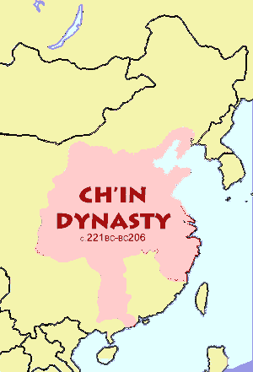
Rulers of the Qin (chin*) dynasty managed to unify China and end the Age of Warring States by 221bce. The Qin rulers clearly explained their laws to the people -- and then strictly enforced them. Qin rulers standardized weights and measures and carried out irrigation projects. The Qin also gave peasant farmers the land they lived on. The West first learned of China during the Qin dynasty. It is from Qin that we get the word China.
A group known as the Legalists influenced the Qin Dynasty. The Legalists believed that a powerful leader and a stable legal system were needed to create social order. The Legalists tried to suppress all thoughts that disagreed with their philosophy. People who discussed ideas not approved by the Legalists faced execution. One Qin ruler ordered 460 scholars to be buried alive because the scholars disagreed with the teachings of the Legalists.
China grew into a great empire during the Han Dynasty, between 202bce and 220ce. Scholars trained in the teachings of Confucius ran the Han governments with great skill. The last Chinese dynasty to rule came from a region of northeast China called Manchuria. The Manchus, also known as the Qing (king*) were weak rulers who were unable to stop other nations from interfering with China.
The British seized Hong Kong in 1841, but more importantly, by the middle of the nineteenth century, had forced the Chinese government to allow them to sell a dangerous drug called opium to the Chinese people. The British defeated the Manchus in a series of conflicts that later became known as the Opium Wars.
In 1894, Japan seized the island of Formosa, which later became known as Taiwan. By the turn of the century, foreigners had overrun China. Parts of China were ruled by the British, French, American, German, Russian, and Japanese forces. The Chinese people believed that the Manchus had lost the Mandate of Heaven. They began to support a group known as the Nationalists, who pledged to free China from foreign rule. The Nationalists had driven out the last of the Manchu rulers, a six year old boy, by 1911.

Timeline of Chinese History

Xia (c. 2200-1766bce) – Chinese oral tradition describes Yu the Great, who organized the people to build canals that stopped flooding and created great prosperity. Most historians once believed the Xia to be a mythical dynasty, but recent archaeological findings seem to verify their existence.
Shang (1766- c.1040bce) -- Excavations have confirmed descriptions in ancient Chinese literature of a highly developed culture. In addition to developing a writing system still in use today, the Shang created a lunar calendar consisting of twelve months of 30 days each. The Shang were distinguished by an aristocratic government, great artistry in bronze, an agricultural economy, and armies of thousands whose commanders rode in chariots.
Zhou (c.1040 - 256bce) -- The nomadic Zhou people from northwestern China overthrew the Shang kings. The Zhou developed a feudal society in China, but slowly lost power to local warlords.
The Age of Warring States (c.481- 221bce) Many regional states formed as the Zhou Dynasty the Mandate of Heaven. This is why the Zhou Dynasty overlaps the Age of Warring States for more than two centuries.
Qin (221-206bce) -- Weights and measures, and the Chinese writing system were unified under the Qin. Chinese defenses against nomadic warriors were strengthened by creating the Great Wall.
Han (206bce - 220ce) -- During the Han Dynasty, the Chinese invented paper, recorded the history of their land, and first learned of Buddhism. The Han is often compared to the Roman Empire of the same age. Today the Chinese word for Chinese person means "a man of Han.”
Sui (589-618) -- The short-lived Sui dynasty reunified China after four hundred years of fragmentation. During Sui rule, a Grand Canal links northern and southern China.
Tang (618-907) – Considered the “Golden Age of China,” the Tang Dynasty made China the largest, wealthiest, and most populous nation of their time. Tang rulers based their laws on based on Confucian thought.
Five Dynasties and Ten Kingdoms (907-960) – Several rival states vied for control of China during a brief period of disunity.
Song (960-1279) -- The Song Dynasty reunified China and ruled for 300 years. Paper money was introduced during the Song dynasty.
Yuan (The Mongols) (1279-1368) -- Kublai Khan established the Yuan Dynasty after his Mongol tribes defeated China. The Yuan encouraged Europeans to travel overland to China; Marco Polo was the most famous of the early Europeans to make the journey.
Ming (1368-1644) -- As famine and plague swept China, the Mandate of Heaven passed to Zhu Yuanzhang, who led a peasant army to victory over the Mongols. The Ming were known for orderly government and control over Chinese peasants.
Qing (The Manchus) (1644-1911) -- Founded by conquerors from Manchuria in 1644, the Qing was the last imperial dynasty of China. Decades of upheaval led to the fall of the Qing.
The Republic of China (1912-1949) – A series of weak governments followed the fall of the Qing. In 1931, Japan seized Manchuria in northeast China and formed the puppet state of Manchuko.
The People’s Republic of China (1949-present) – A Communist revolution led by Mao Zedong captured control of China in 1949. The communists continued to rule long after Mao’s death in 1976.

Fill in the Blanks
NOTE: Use the text and the Timeline of Chinese History to complete this exercise.
For most of the last four t__o__s__nd years, China has been ruled by f__m__li__s who passed control from one g__n__ra__i__n to the next. The families are known as d__n__s__i__s. The ancient Chinese people believed their rulers were granted the M__n__a__e of H__a__en by Chinese a__c__s__o__s.
The Shang were the first Chinese dynasty to leave w__i__t__n records, though there are indications of an earlier X____ Dynasty. During their *s__v__n centuries of rule, the S__a__g dominated the land between present day M__n__ol__a and the P__c__f__c Ocean.
Zhou warriors o__e__t__r__w the Shang. The Zhou were n__m__d__c warriors from W__s__e__n China who made powerful w__a__o__s from i______. The Zhou appointed n__bl__s to manage their f__u__al government. In time, the noble families became stronger than the Zhou, leading China to a period of instability now called the A__e of W__r__i__g S__a__es.
The Qin Dynasty r__u__i__i_d China in 221bce. Qin rulers were influenced by the L__g__l__st philosophy that taught China needed strong leadership with clearly explained laws. Though the Qin ruled for less than *s__x__een years, the word China derives from the Q____.
The H____ Dynasty replaced the Qin in 202bce. The Han is often compared to the R__m__n Empire of the same time. Han governments relied on s_h__l__rs trained in the teachings of C__n__u__i__s to run their governments.
Following the Han, China was governed by several dynasties that included the S__i, the T______, the S____g, and the M__ng__l Yuan Dynasty. The final Chinese Dynasty were the Qing from M__n__h__r__a in n__r__h__a__t China. The Qing were weak rulers who were unable to stop the B__i__i__h from selling o__i__m in China.
After being dominated by *f__r__i__n governments for years, the Chinese people defeated the Qing and established a r__p__b__ic in 1911. A c__m__u__i__t revolution led by M____ Z__d__ng overthrew the Chinese republican government in 1949.
Timeline
*1. On the timeline below, identify the eras of the Xia and Zhou Dynasties, the Age of Warring States, and the Xin Dynasty. Remember that the Zhou Dynasty and the Age of Warring States will overlap.

2200  BCE |  |  |  |  | 2000  BCE |  |  |  |  |  | 1800  BCE |  |  |  |  |  | 1600  BCE |  |  |  |  | 1400  BCE |  |  |  |  |  | 1200  BCE |  |  |  |  |  | 1000  BCE |  |  |  |  |  | 800  BCE |  |  |  |  | 600  BCE |  |  |  |  |  | 400  BCE |  |  |  |  |  | 200  BCE |  |  |  |  | 1  CE
*2. On the timeline below, identify the eras of the Han, Sui, Tang, Song, Yuan, Ming, and Qing Dynasties. Identify the date of Mao Zedong’s Communist revolution by writing “Mao.”

200  BCE |  |  |  |  | 1  CE |  |  |  |  |  | 200  CE |  |  |  |  |  | 400  CE |  |  |  |  | 600  CE |  |  |  |  |  | 800  CE |  |  |  |  |  | 1000  CE |  |  |  |  |  | 1200  CE |  |  |  |  | 1400  CE |  |  |  |  |  | 1600  CE |  |  |  |  |  | 1800  CE |  |  |  |  | 2000  CE
Answer in complete sentences
*1. What was the Mandate of Heaven?
*2. Why do we not know if any dynasties preceded the Shang?
*3. Were the Manchus a strong or a weak dynasty? Support your answers with facts from the text or outside research.
4. Why did many Chinese people support the Nationalists at the beginning of the twentieth century?

