Harappa and Mohenjo Daro

In 1856, a group of British railroad engineers uncovered an ancient and advanced civilization. The engineers were laying tracks through the Indus River Valley in present day Pakistan. They searched the area for stone to make ballast. Ballast is crushed rock placed around railroad tracks to drain water from the path of the train. The engineers found bricks that seemed very old, but were formed exactly alike. The local people told the engineers of the ruins of an ancient city made of the same bricks. The engineers soon realized that the bricks were part of one of the earliest advanced civilizations in history.
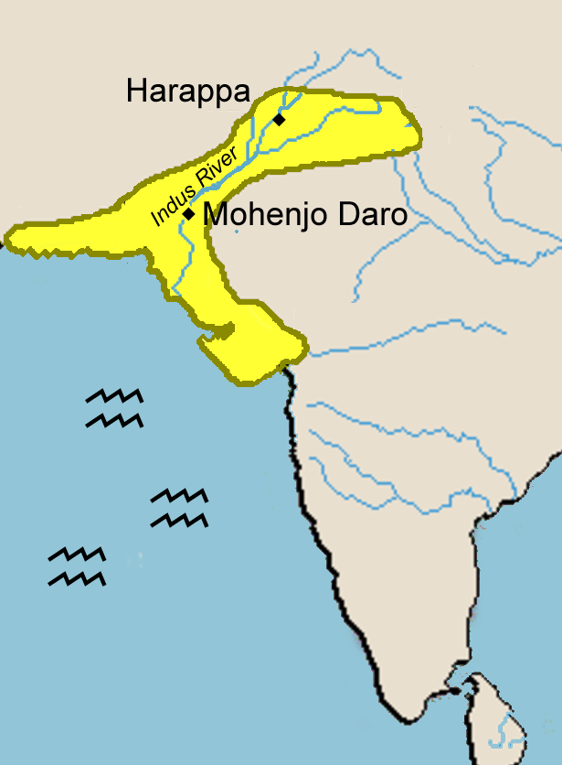
Archaeologists later discovered more than 1500 additional settlements along the banks of the Indus River. As with Mesopotamia and Egypt, the river’s silt provided the civilization with rich topsoil for farming.
Thousands of clay tablets indicate that the people of the Indus River Valley developed a writing system that may be even older than Sumerian writing. Archaeologists have not yet deciphered the writing of the Indus River Valley civilization, so their form of government, their religious beliefs, and the social structure of their society remain a mystery.
The Indus River civilization developed about 3000bce and flourished for about 1500 years before mysteriously going into a period of decline. We don’t know what those ancient people called the cities they lived in, but we now refer to the two largest as Harappa, after a nearby village, and Mohenjo Daro, a local term that means “hill of the dead.”
Harappa and Mohenjo Daro were expertly planned cities built with a grid pattern of wide, straight streets. Thick walls surrounded the cities. Many people lived in sturdy brick houses that had as many as three floors. Some houses had bathrooms and toilets that connected to the world’s first sewer system. An irrigation system of canals provided a reliable source of water for growing wheat and barley. There is also evidence that people herded sheep, cattle and goats.
The ancient people of the Indus River Valley had a highly advanced knowledge of mathematics and a sophisticated system of weights and measures. The bricks–even those used in different cities–are the same size, suggesting that the cities may have had the same government.
Archaeologists have also found evidence of musical instruments, toys and games, and pottery. The people of the Indus River valley were very interested in cleanliness. Excavators have uncovered evidence of combs, soaps, and medicine. The cities were also practicing some form of dentistry. We know this because archaeologists found a gravesite with the remains of people whose teeth had been drilled.
The Indus River Valley cities traded with distant foreign cultures. Archaeologists have found jewelry made in Harappa as far away as Mesopotamia. Traders also sold cotton cloth and hardwood from the teak trees that grew in the valley.
Ancient cities along the Indus River Valley may have been home to more than five million people, but the civilization went into decline about 1700bce and seems to have been abandoned by about 1500bce. Archaeologists have many ideas from the clues left behind, but no definite answers.
Perhaps a natural disaster could have destroyed the civilization. There may have been a prolonged drought, or the moving tectonic plates that created the Himalayas may have caused a devastating earthquake. Some evidence suggests the Indus Valley cities were invaded by nomadic warriors who destroyed their advanced culture.
It is also possible that the people of the Indus Valley cities may have unintentionally destroyed their environment. They may have overgrazed their land, exhausted their soil, or cut down the forests in their region. The people may have been left without wood for building and fuel, and without the trees to hold the topsoil in place, the land was vulnerable to severe flooding.
Archaeologists have excavated only a fraction of the many cities and settlements of the Indus River Valley civilization, so our understanding of the region is still evolving. Perhaps we may one day decipher their writing so we can learn how these ancient cities developed, how their citizens learned to create an advanced civilization, and why the cities were eventually abandoned.

Fill in the Blanks
In 1856, the people of the I__d__s River Valley in present day P__k__s__an told British r__il__o__d engineers of the ruins of an ancient c__v__l__z__t__on. Archaeologists later unearthed more than one thousand settlements of whose p__p__l__t__on was greater than five m__l__i__n people. There is much we have not yet learned, but we do know the region was thriving ________ years ago, perhaps even earlier than civilizations in M__s__p__t__m__a and E__y__t. The ancient people of the I__d__s River V__l__ey lived in b__i__k houses with as many as t__r__e floors. The houses had b__t__r__o__s and t__i__e__s that connected to a s__w__r system that would not be matched in history until the era of the *R__m__n Empire. There is also a__c__a__o__o__i__al evidence that the people of the ancient Indus R__v__r Valley traded with cultures as far away as M__s__p__t__m__a.
The Indus River civilization mysteriously went into a period of d__c__i__e about ________ years ago. Scientists have many theories why the civilization was *ab__nd__n__d, but our best hope for understanding more about the people and culture of the ancient Indus River Valley is in finding a *“R__s__tta St__ne” to unlock the secrets of their w__i__i__g.

Answer in complete sentences
1. Where are Mohenjo-Daro and Harappa?
2. Describe the houses where the people of Mohenjo-Daro and Harappa lived.
*3. The text states, “The bricks in different cities are the exact same size. This suggests that the cities may have had the same government. Why would the having the same size brick in many areas suggest there was a government?
4. Explain how archaeologists decided that the Indus River civilization valued art and traded with away places.

*5. Why don’t we know what happened to Mohenjo-Daro and Harappa?
*This is a higher order learning question. You must answer the question to the best of your ability, but any reasonable answer will be graded as correct.

