The Aryans and the Vedas

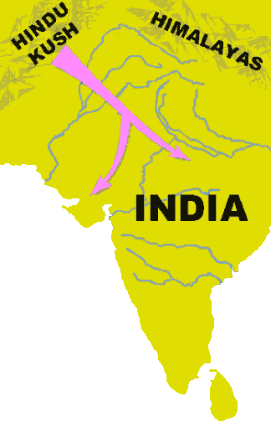
The Aryans were warriors that first appeared in northern India about 1500bce. Most Aryans were nomadic cattle herders, who occasionally practiced slash-and-burn agriculture. A band of Aryans would slash, or cut, the trees on a plot of land to create a field. Months later, when the vegetation had dried, they set it on fire. The ashes left from the fire fertilized the soil for a few growing seasons. The Aryans would repeat the process in a new area once the soil had been exhausted. The Aryans did not remain in one place for long, so unlike the Indus River Valley culture that preceded them in the region, the Aryans did not build permanent homes.
The Aryans were skilled warriors. Their experience as cattle herders made them able horsemen. Like the Assyrians of Mesopotamia, the Aryans built chariots with spoke wheels, which were faster and easier to control than chariots with solid wheels.
Their military skills allowed bands of Aryans to subjugate the native Dravidian people and to spread their language and culture to most of the subcontinent.
About 1000bce, the Aryans discovered iron ore in the Ganges River Valley. The heavy monsoon rains created dense vegetation in the valley. When the Aryans cleared the trees and brush, they discovered fertile land that allowed them to permanently farm along the banks of the Ganges. Within 500 years, the several villages the Aryans had formed had grown into small states.
The Aryans spoke Sanskrit, a language that is similar to many European languages but unlike the Dravidian languages spoken in India before the Aryan invasion. The similarities with European languages suggest the Aryans came through the tall mountains of the Hindu Kush from present-day Afghanistan. However, we cannot be sure because there are no stories of a great journey to be found in the songs and poems of the Aryan people.
The first Aryans on the subcontinent could not read or write, but they did have a rich oral tradition. For hundreds of years, Aryan songs and epic poems were handed down by word of mouth.
About 500bce, the Aryans began to compose a body of texts called Vedas based on their traditional stories. Veda is a Sanskrit word that means knowledge. The Rig Veda is a collection of more than 1000 poems that survives to this day. The influence of these stories of the Aryan people on the subcontinent is why historians label the period of Indian history lasting from about 1500bce to 322bce as the Vedic Age.

Answer in Complete Sentences
*1. Explain why the first Aryans did not remain in one place for very long.

Fill in the Blanks
The Aryans were n__m_d__c warriors who apparently reached the Indian s_b__o__t__n__nt from Central *A______ by crossing the H__n__u Kush. The first Aryans on the Indian subcontinent were c__tt__e herders who occasionally practiced s__a__h-and-b____n agriculture. The Aryans discovered i______ ore in the G__n__es River Valley, so they fashioned *m__t__l tools to clear the lush* v__g__t__t__on that resulted from the annual m__n__o__n rains. The fertile land along the Ganges allowed the Aryans to build permanent f________.
The first Aryans were illiterate, but by about 500bce, the Aryans composed a collection of stories, songs and scripture they called the V__d__s. Historians often label the period of 1500bce to 322bce the V__d__c Age because of the influence of the Aryans and their texts on the Indian subcontinent.

Answer in Complete Sentences

- How did the first Aryans farmers fertilize their soil?
*3. Why was the discovery of iron in the Ganges River Valley significant to the Aryans?
- Why do many historians believe the Aryans migrated from Central Asia to the Indian subcontinent?
- What are the Vedas?
- Why do historians label the period of Indian history lasting from about 1500bce to 322bce as the Vedic Age?

