Maafa

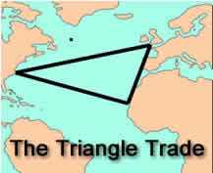
Maafa is a Kiswahili term for "disaster" or "terrible occurrence.” It is used to describe more than five hundred years of exploitation of Africa through slavery, colonialism, and imperialism. A colony is a settlement in one land supported by another land, and imperialism is the practice of building empires to support trade.

The barbarous “triangle trade” began shortly after Europeans began exploring the west coast of Africa. Ships leaving Europe first stopped in Africa where they traded weapons, ammunition, metal, liquor, and cloth for captives taken in wars or raids. The ships then traveled to America, where slaves were exchanged for sugar, rum, salt, and other island products. The ships completed the triangle loaded with products popular with the European people, and were ready to begin their journey again.

The Europeans explored the interior of Africa to expand trade. By the 1880s a “scramble for Africa” occurred. Five European powers--Britain, France, Germany, Belgium, and Italy--colonized almost the entire continent by 1900. They exploited the great mineral wealth of Africa and sought to expand their borders by moving into the continent.

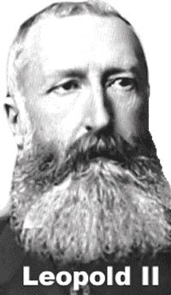
The colonial rulers were often cruel and had little regard for the Africans. King Leopold II of Belgium obtained personal title to the Congo in central Africa. He forced the native people to work under cruel conditions in his rubber plants. Every village was required to donate four people a year to work for Leopold. Villagers who failed to complete their duties were flogged; others had their hands or their heads cut off. When the Belgian government learned what was happening, they took Leopold’s grotesque colony from him and made reforms.

France attempted to annex Algeria in the 1830s, but made little effort to understand the Muslim Berbers who lived there. The Algerians resisted, often violently. The French finally withdrew from the colony in 1962 after the Algerians voted 6,000,000 to 16,000 to ask the French to leave.

Answer in Complete Sentences
1. What does maafa describe?
2. What is a colony?

Answer in complete sentences
3. What is imperialism?
*4. What was the triangle trade.
5. Why were Britain, France, Germany, Belgium, and Italy involved in the “scramble for Africa?”
*6. What is the dictionary definition of annex?
*7. Why do you think the people of Belgium took control of Congo and made reforms?
*8. Explain why the people of Algeria were united in demanding that the French leave?

