THE FERTILE CRESCENT

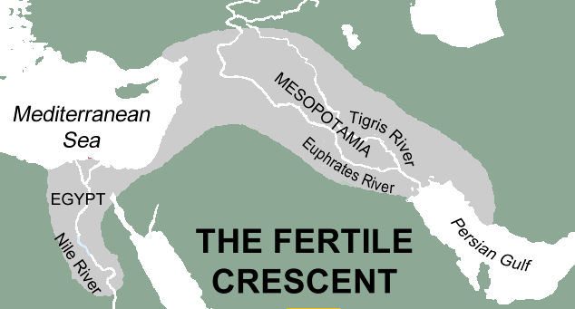
Before they settled down in various parts of the world, humans lived as nomads for tens of thousands of years. Nomads are people who have no permanent home and travel in search of food and safety.
A typical nomadic group might include an extended family of about ten adults and their children. They would temporarily camp in an area for a few weeks or months -- the men hunting animals and the women gathering fruit, grains, seeds and nuts. When the nomads exhausted the resources in that area they moved on.
Civilization developed slowly in different parts of the world. People began to settle in areas with abundant natural resources. For thousands of years, people have been attracted to a part of the world archaeologists later called the Fertile Crescent.
The Fertile Crescent is a boomerang-shaped region that extends from the eastern shore of the Mediterranean Sea to the Persian Gulf. It is a rich food-growing area in a part of the world where most of the land is too dry for farming.
Some of the best farmland of the Fertile Crescent is on a narrow strip of land between the Tigris and the Euphrates Rivers. The two rivers travel in the same direction for thousands of miles before they combine to drain into the Persian Gulf. The Greeks called this area Mesopotamia, which means "between the rivers." Very little rain falls in Mesopotamia, but water and nutrients from the river soak into the land, creating an environment filled with plants and the animals that feed on the vegetation.

Many different civilizations flourished in this small region. The Sumerians slowly developed one of the first civilizations in the southeastern section of Mesopotamia as early as 7,500 years ago. The Sumerian civilization lasted more than three thousand years, but in time the Sumerians lost their influence. The Babylonians formed a centralized government under King Hammurabi. The Babylonian culture lasted from about 1770bce s to about 1595bce. Various other cultures dominated part or all of the Fertile Crescent including Amorites, the Kassites, (c. 1531-1155bce) the Hittites (c. 1370 – 1205bce) and the Assyrians (c.890-600bce). The land known as Mesopotamia was later controlled by the Persians, the Greeks under Alexander the Great, the Romans, and the Ottoman Turks. The land between the Tigris and Euphrates has been part of the modern nation of Iraq since 1932.
NATURAL BOUNDARIES
The Tigris and Euphrates are natural boundaries that were formed by nature instead of being drawn by people. Examples of natural boundaries include rivers, mountain ranges, or deserts.
Straight lines on a map generally signify borders made by people, while natural borders can follow many different paths. This is easy to demonstrate on a map of the United States. Most of the boundaries of the western states are straight lines; Colorado and Wyoming and rectangles. Many eastern states have jagged shapes because their borders are formed by rivers.

Fill in the Blanks
About 7,500 years ago, a group of people gave up their n__m__d__c lifestyles to settle in the area between the T__g__is and the E__p__r__t__s Rivers. The Greeks later called this land M__s__p__t__m__a, which means “b__t__e__n the r__v__rs.” Mesopotamia is part of the F__r__i__e C__e__c__nt, a b_o__e__a__g -shaped region that extends from the e__s__e__n shore of the M__d__t__r__a__e__n Sea to the P__r__i__n Gulf.
Several civilizations developed in Mesopotamia partly because the rivers provide the region with ab__n__a__t natural r__s__u__c__s. The S__m__r__a_s first settled near the confluence of the rivers about _______bc. Later Mesopotamian c__v__l__z__t__o__s included the B_b__l__n_a__s and the A__s__r__a__s. Mesopotamia was later controlled by the P__r__i__ns, the G__e__ks, and the R__m__ns. Mesopotamia is now part of the m__d__rn nation of I______.

Timeline
5500 5000 4500 4000 3500 3000 2500 2000 1500 1000 500 500 1000 1500 2000
BCE BCE BCE BCE BCE BCE BCE BCE BCE BCE BCE CE CE CE CE
- Identify on the timeline the periods when the following civilizations flourished in Mesopotamia: the Sumerians, the Babylonians, the Kassites, the Hittites, the Assyrians, modern Iraq. Note that the civilizations may overlap.

Answer in complete sentences
2. What is the Fertile Crescent?
*3. What is the dictionary definition of crescent? Can you think of a food whose name in French means crescent? Write it at the very bottom of the page if you can think of it.
*4. Why do you think people choose to settle in areas with abundant natural resources?
*5. What are the natural boundaries of Mesopotamia? Why do we call the land Mesopotamia?
*This is a higher order learning question. You must answer the question to the best of your ability, but any reasonable answer will be graded as correct.

