Name: | 
Date:
ABRAHAM MASLOW’S HIERARCHY OF NEEDS

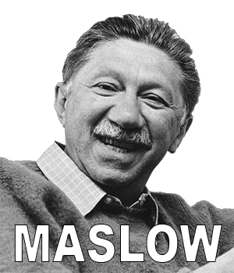
Psychologists study mental processes and behavior. Abraham Maslow (born 1908 – died 1970) focused his research on people who were satisfied with their lives. He decided that people want to be happy and loving, but that many of us have unmet needs that keep us from being satisfied.
Maslow believed most of us want more than we have. Once our most basic needs are met, we then add on higher needs. “As one desire is satisfied,” Maslow observed, “another pops up in its place.”
Maslow illustrated his theory with a pyramid he called the Hierarchy of Needs. He argued that once lower level needs are met, people develop additional needs until they reach a stage the psychologist called “self-actualization.” Maslow's Hierarchy of Needs includes five levels:

- Physiological needs. These are biological necessities such as food, water, and oxygen. These requirements are the strongest because a person would die if they were not satisfied.
- Safety needs. People often feel unsafe during emergencies or times of disorder such as rioting. Young children commonly feel afraid when their safety needs have not been met.
- Love and belonging needs. These would include the need to escape loneliness and alienation, to give and receive love, and a have sense of being a part of a group. Love and belonging needs are usually met within a family.
- Friendship and esteem needs. These needs are fulfilled by a sense of value, having self-respect, and to be highly regarded by others. If a person does not fulfill their esteem needs, he or she feels inferior, weak, helpless, and worthless.
- Self-actualization needs. Maslow taught that a very small group of people reaches a level called self-actualization, where all of their needs are met. Maslow described this state as a person finding their “calling.” He said, “a musician must make music, an artist must paint, and a poet must write.”

Many people confuse self-actualization with fame or fortune, but often this is not the case. While wealthy or celebrated people might reach self-actualization, many people who have reached the highest level of happiness are unknown beyond their circle of family and friends.
According to Maslow’s theory, civilization developed because people wanted more and sought to improve their circumstances.

Fill in the Blanks
Abraham Maslow was a psychologist who observed that humans will always w______ more than they h______. Maslow described a H__e__a__hy of N__e__s. He said the most elementary *h__m__n needs are f______, water and o__y__e__. Once those b__s__c needs are met, Maslow said that h__m__ns seek s__f__ty.
According to Maslow, most people will always w______ more than they have, but there are some rare exceptions. According to M__________, a s________ group of people reach s______-a__t__a__i__z__i__n where they are completely h__p__y, and all of their n__e__s are met.

Name:
Date:

Answer in complete sentences
*1. Refer to Maslow’s hierarchy of needs. Describe at least three things that would keep you from being a good student if your most important needs were not met.
*2. Write a short sentence describing how you do meet or could meet each of Maslow’s Hierarchy of Needs.
^{Physiological Needs:}
^{Safety Needs:}
^{Love and Belonging Needs:}
^{Esteem Needs:}
*3. What do you feel you need in order to reach self-actualization?
*4. Think of a famous person who you believe has reached self-actualization. Describe why you believe they have reached this state. (You might consider Oprah Winfrey, Bill Gates, Michael Jordan or anyone else.)
*5. What would your parent need to reach self-actualization?
(You may ask a parent to write this answer for you. If a parent is not available, think of your best answer on your own.)

