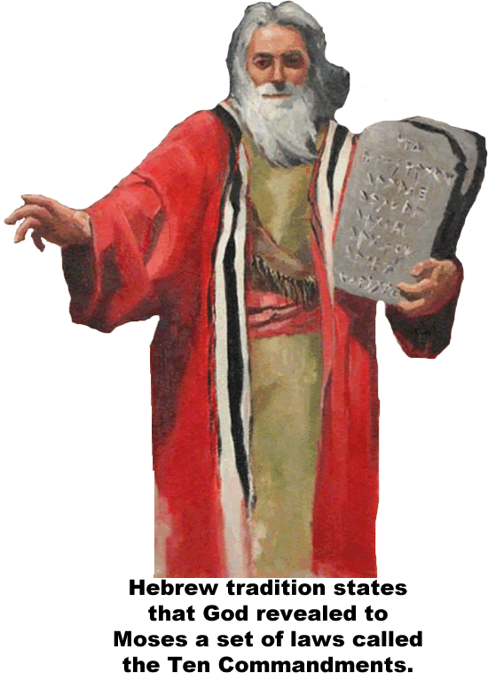
THE HEBREWS

The Hebrews were the ancestors of the modern Jewish people. Most cultures of the ancient world believed in many gods, but the Hebrews were monotheistic; they believed in only one God.
The Hebrews have a written tradition called scripture that refers to events from 4000 years ago. According to Hebrew scripture, God told Abraham to leave his home in Mesopotamia and travel with his family to a land on the Mediterranean Sea. God granted the land to Abraham and his family, so it became known as the Promised Land. The Hebrews believed they had a special relationship with their God and that they were God’s chosen people.
The Hebrews traveled to Egypt to escape a famine. A famine is a period of great hunger. For hundreds of years the Egyptians treated the Hebrews well, but as the descendants of Abraham began to outnumber the Egyptians, the pharaoh, or king of Egypt, enslaved and mistreated the Hebrews.
Moses became a leader of the Hebrews. According to Hebrew scripture, God told Moses to lead the Hebrews back to the Promised Land. God sent ten deadly plagues to Egypt when the Egyptians would not release the Hebrews from slavery. When the Hebrews did escape, scripture states that Moses parted the Red Sea for just enough time to allow the Hebrews to pass.
The Hebrews wandered through the desert for forty years before returning to their home. The passage from slavery in Egypt back to their home in the Promised Land is remembered by the Hebrews every year in a celebration called Passover.
While on their journey back to the Promised Land, the Hebrews stopped at Mount Sinai. There God revealed to Moses a set of laws called the Ten Commandments. The Ten Commandments became the model for both Jewish and Christian moral thought.
Upon their return to the Promised Land, the Hebrews established a nation they called Israel. One of Israel’s greatest leaders was Solomon. Solomon married the daughter of an Egyptian pharaoh and established a friendly relationship between Israel and Egypt. Both nations grew strong during this period of peace, and Solomon used his great wealth to build a magnificent temple in Jerusalem, Israel’s greatest city.
The kingdom of Israel became a secular nation. Secular refers to attitudes and activities that have no religious or spiritual basis. Over the course of many years, the word Hebrew became associated with a nation that was willing to absorb new teachings and ideas. The word Hebrew no longer held a spiritual meaning to the people of Israel, so religious leaders began to refer to themselves as Jews.
In 586bce, the Babylonians of Mesopotamia destroyed Solomon’s temple. The Jews were exiled, or forced from their homes, and made to move to Babylon. The Jews continued to practice their faith by praying and reading their holy texts. The holiest book of the Jews, the Torah, became part of the Old Testament of the Christian Bible.
About fifty years after the Jews were exiled to Babylon, a Persian leader named Cyrus allowed the Jews to return to their homeland and to rebuild their temple. Many years later, Israel fell to the Roman army. The Jews revolted against Rome in 66ce, so the Romans destroyed their temple and forced the Jews to once again leave Israel and live in exile.
For the next 1,800 years, most Jews lived as minorities in other lands. The Jews remained united despite often severe treatment. European Jews were ordered to leave Spain by King Ferdinand and Queen Isabella in 1492.
The Jews also faced organized massacres called pogroms in many nations, particularly in Eastern Europe. In the last century, as many as six million Jews were murdered in the Holocaust, where the Nazi party of Germany attempted genocide, or the planned killing of a whole group of people because of their religion or nationality.
In 1948, the United Nations created a homeland for the Jewish people on the land the Hebrews once occupied. This homeland became the modern nation of Israel. Many of the Arab people who lived in the region did not believe the United Nations had the right to create a homeland for Jewish people on land they considered to be Arab. Several wars and a great deal of violence followed, but Israel continues to be a Jewish homeland, coexisting in an often uneasy relationship with many of its neighbors.

Fill in the Blanks

The Hebrews were the a__c__s__o__s of the J__w__sh people. The Hebrews were m__n__t__e__s__s who believed in one God. They trace their identity to A__r__h__m, who led his followers through the d__s__rt to settle on the eastern shore of the M__d__t__r__a__e__n Sea about *f______ thousand years ago. Many years after A__r__h__m died, his followers traveled to E________ to escape a great hunger known as a f__m__ne. According to Hebrew s__r__p__u__e, God sent ten deadly calamities to force the Egyptian pharaoh to r__l__a__e his Hebrew slaves. Once the H__b__e__s escaped, God revealed Ten C__m__a__d__e__ts to M__s__s, the leader of the Hebrews. The Ten Commandments are the m__d__l for J__w__sh and C__r__s__i__n moral thought.
The Hebrews prospered under S__l__m__n and built a great city called J__r__s__l__m, but the city was destroyed in 586bce by the B__b__l__n__a__s of M__s__p__t__m__a. The Jews returned to Jerusalem under the protection of a P__r__i__n leader named C__r__s, but a later conqueror, the R__m__ns, forced the Jews into an e_________ that lasted almost two thousand years.
The Jews lived as m__n__r__t__es in many lands, often facing organized massacres known as p__g__o__s. In the last century, as many a six million Jews were killed in what we now call the H__l__c__u__t. In 1948, the U__i__ed N__t__o__s created the modern nation of I__r__el as a h__m__l__nd for Jews.

Answer in complete sentences
*1. What might be the cause of a famine? Answer in complete sentences
*2. Where might you live if you were exiled? Explain your answer.
3. Why did the Jews live as minorities in many lands for almost two thousand years?
4. Why does the modern nation of Israel have an uneasy relationship with many of its neighbors?

