Name:
Date:

Technology

Technology is the tools and skills used to build things. Today we live in a world with amazing machines, but we can trace our modern tools to rocks. Early humans used stone tools, and those tools were the first technology. “Stone Age” humans used rocks as weapons, to break open things and to sharpen softer objects.

About ten thousand years ago, people discovered that metal could be extracted from ores. An ore is a rock that contains minerals that include metal. Civilizations discovered metal long before they developed writing, so it isn’t possible to know how ancient civilizations smelted their metals. It is likely that people discovered that particular rocks might include a material that could be molded into different shapes.

Copper was likely the first metal many civilizations discovered. Copper becomes stronger when it is mixed with other metals. A combination of two metals is called an alloy. The combination of copper and other metals such as tin is called bronze. Tools and weapons made of bronze were stronger and lasted longer than those made from copper, wood or stone.

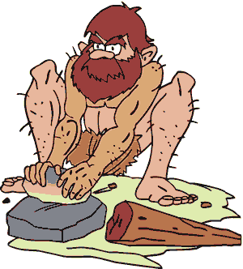
Iron was the even harder and stronger than bronze, but iron requires more heat to smelt than bronze or other metals. Iron artifacts have been found in modern Turkey that date back to 2500BC. The discovery of iron made it possible for the advancement of many civilizations in different parts of the world. The discovery of these metals is so significant that scholars often divide early civilizations into the Stone Age, the Bronze Age and the Iron Age.

Fill in the Blanks

Technology is the t________ and s__________ used to b________ things. S________ tools were the first t_________________. Early h___________ used *r_________ for many purposes, and years later they discovered something *i__________ the rocks. When rocks were left in a f______ for a long time, something began to *l____k. The leaking material was m________. Once a culture discovered m________, they left the s________ age and entered the i______ age.

Answer in complete sentences
*1. Use a college level dictionary to find the definition of technology. (Don’t use my definition)
*2. How do you think many cultures used iron to conquer other people or to advance their civilization? (Try your best on this question. It is very difficult, but try to stretch your mind.)

