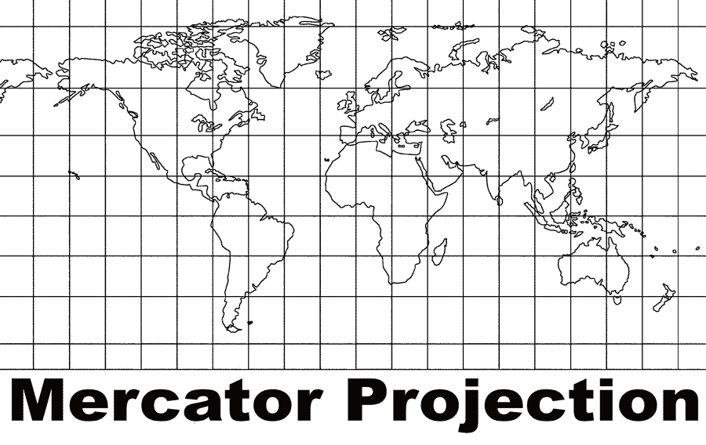
MAP PROJECTIONS

You have probably looked at a tennis ball. But have you looked at the entire tennis ball all at once? To do so you would have to flatten the tennis ball by applying enough force so that the sides would split and its round shape would change. The same thing would happen if you tried to look at a map of the world all at once. You would have to flatten a globe onto a piece of paper.
A globe can show size, shape, distance, and direction accurately in three dimensions, but turning that globe’s surface into a flat, that is, a two-dimensional map of the three-dimensional earth you would have to stretch some areas of the flat map. Mapmakers call this stretching distortion.
For more than four hundred years, mapmakers have used mathematics to help them by creating algorithms that could translate the globe into a flat object. An algorithm is a set of rules for solving a problem.
Flat world maps use algorithms to create a projection. A map projection is a way to show a drawing of the earth on a flat surface. All flat maps have distortion, so the shape, distance, direction, and land area can never be completely accurate. This distortion is a trade-off. But we accept the trade-off, since we use different map projections to meet various needs.
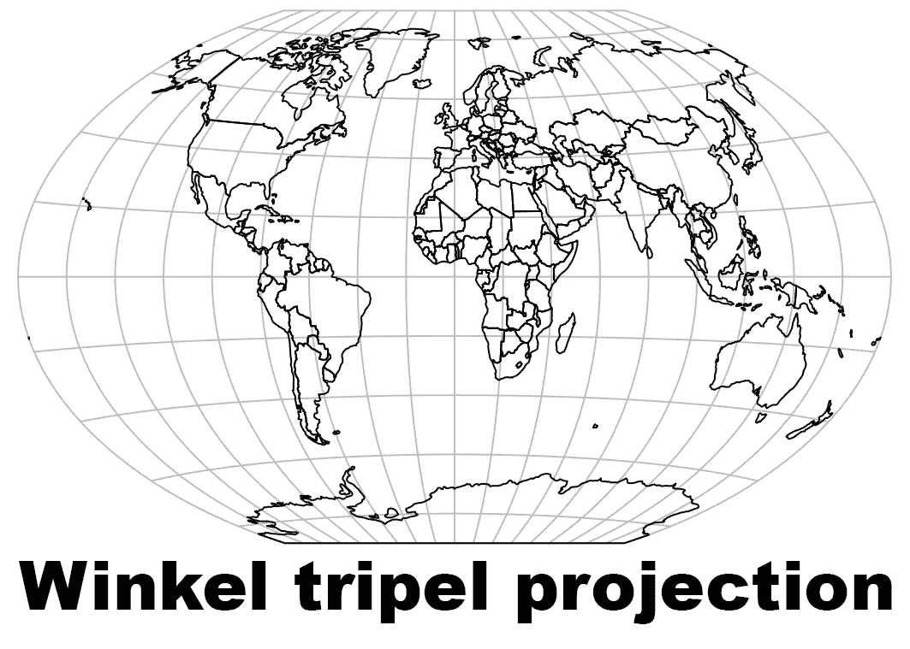
In 1569, Gerardus Mercator created a map where parallels and meridians cross at right angles. The so-called Mercator Projection is excellent for navigation because it shows direction clearly. The Mercator Projection, however, has a great deal of distortion. This is because to get the parallels and meridians to cross at right angles, Mercator created an algorithm that stretched the areas closer to the poles and squeezed the areas closer to the equator.
An equal area map displays the shapes and sizes of things more accurately than a Mercator Projection. The Winkel tripel projection is one of several equal area maps. The Winkel tripel Projection sacrifices accuracy of angle and shape in favor of accurate proportions in area. Tripel is a German word that translates as triple because the projection minimizes area, direction, and distance.
Compare Greenland and Africa on the two projections. Africa is fourteen times larger than Greenland, but on a Mercator Projection, the two regions bodies of land appear to be about the same size.
Colorado and Wyoming look like rectangles on most map projections, but because of the curvature of the earth, the northern borders of both states are slightly more than twenty miles shorter than their southern borders. The border of the western United States and Canada is the longest straight border in the world. Some map projections depict the border as a straight line while on other map projections you will notice a slight bend due to the curvature of the earth.

Fill in the Blanks

The earth is a three-d__m__n__i__n__l object, so it is impossible to create a flat map without *d__s__o__t__ng some sections. A flat map uses an a__g__r__t__m to create a p__o__e__ti__n. Because no projection can show the shape, distance, direction, and land area with complete *a__c__r__cy, mapmakers have created many projections.

Nearly 450 years ago, Gerardus M__r__a__or created a map where Lines of *L__t__t__de and Lines of *L__n__i__u__e cross at r__g__t angles. Mercator's projection accurately shows d__r__c__i__n, but it has a great deal of d__s__o__ti__n. Greenland appears to be nearly the same size as Africa on a M__r__a__or Pr__j__c__i__n but Africa is almost f__u__te__n times the size of Greenland.

An equal area map trades accuracy of a__g__e and s__a__e to show areas p__o__o__t__on__l to their actual size.

Answer in Complete Sentences
*1. Explain why it is impossible to display a map of the world on a flat surface without stretching or shrinking some places.
2. What is an algorithm?
3. What is a map projection?
*4. What part of the earth is “squeezed” into a smaller area by the Mercator Projection? Why?
*This is a higher order learning question. You must answer the question to the best of your ability, but any reasonable answer will be graded as correct.

