zzz
Name:
Date:

Longitude and Latitude

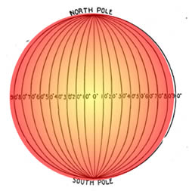
The grid of intersecting lines on a globe enables us to identify every location on earth with a set of numbers or letters The ancient Babylonians divided any circle or sphere into 360 degrees. The symbol for degree is °. Ptolemy was a Greek thinker who borrowed the Babylonians’ ideas as he wrote one of the first books on geography. Ptolemy wrote that the furthest point at the right or left side of a circle or a sphere is 90 degrees from the top. There are 180 degrees between any two sides of a circle or sphere. This means that the north and south poles are 180 degrees apart from one another, and both poles are 90 degrees from the equator. Geographers use Ptolemy’s calculations to create Lines of Latitude and Lines of Longitude. The horizontal lines that circle the globe are called Lines of Latitude. Lines of Latitude are also known as parallels because they parallel, or run in the same direction as the equator.

Lines of Latitude are imaginary lines that circle the globe from east to west. Lines of Latitude are called parallels because the lines parallel, or run in the same direction as the equator. The equator is the imaginary line that is as far away from the North Pole as it is from the South Pole. Lines of Longitude intersect the equator at right angles but end at the North and the South Poles. Lines of Longitude are also called meridians. Meridian comes from a Latin word that means midday. The sun crosses each meridian in the middle point between sunrise and sunset.

In 1884, the International Meridian Conference chose to make the line at 0° longitude run through the Royal Observatory in Greenwich, England, though they could have chosen any spot on earth. They called the line at 0° longitude the prime meridian. Meridians are counted east and west from the prime meridian. St. Louis, Missouri is 90° west of the prime meridian, so it is one-fourth of the way around the earth from the prime meridian. The International Date Line is 180°--as far away as possible--from the prime meridian. When it is noon along the prime meridian, it is midnight along the International Date Line.

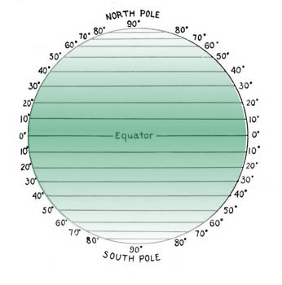
Geographers also divide the earth into hemispheres. Hemi- is a prefix that means half. Everything north of the equator is in the Northern Hemisphere while everything south of the equator is in the Southern Hemisphere. The Western Hemisphere is west of the prime meridian and the Eastern Hemisphere is east of the prime meridian. The hemispheres both end at the International Date Line. The United States is in the Northern and Western Hemispheres. The White House in Washington, D.C. is 80 degrees west of the prime meridian and 26 degrees north of the equator, or 39°N,77°W.

Answer in complete sentences
1. How many degrees are in a circle?
2. What is the equator?

Name:
Date:

Fill in the Blanks
Our *p__________ is a sphere. The ancient Babylonians divided spheres or c__________ into ______ degrees. Most Americans use a base ten numeral system, but Babylonian arithmetic used a place-valued sexagesimal system. The Babylonian base sixty is still used in measuring time. Sixty *s____________ equal one minute; 60 minutes equal one *h______.
Geographers created an imaginary grid to help locate places on earth. Lines of Latitude, or p________________, circle the globe from e______ to w______. 0º latitude is known as the e____________. The north and south p________ are ____ º from the equator. Lines of L________________, or m________________, run north to south. The p__i__e m__r__di__n runs through G________________, England.
The hour of the day is determined mostly by what part of the earth faces the *s____. When it is noon in Greenwich, it’s close to *m______________ along the I_______________________ D______ L______ because that line is about ______ º from the Prime Meridian, or *h__l__w__y around the world. The h______ of the day changes as you move e______ or w______ because you are moving closer to or further away from the s____. West Palm Beach, Florida is at ____º north and 80º w______. This means we are 26º north of the e____________ and ____ degrees away from the Prime Meridian.

Answer in complete sentences
3. What imaginary lines parallel the globe from east to west?
*4. West Palm Beach, Florida is at 27ºN,80ºW. Explain what 27ºN,80ºW means.
5. Find the longitude and latitude of your home or school by going to http://www.worldatlas.com/aatlas/latitude_and_longitude_finder.htm
*This is a higher order learning question. You must answer the question to the best of your ability, but any reasonable answer will be graded as correct.

